RRC M4 New and Noteworthy
This is an informal N&N for RRC M4. It will be part of the official M5 N&N, when it is posted to jazz.net.

Icons per Artifact Type

Artifact types can now be associated with a 'custom' icon, chosen from a system palette. For 3.5, there will be a limitation: Images will not be able to be uploaded, and selection must be from the ones provided in the palette. Once chosen, all artifacts of that type will be shown with that icon.

Note: The icon palette shown in the images below are not the real set of icons, and will not be in official M4/self-host . We will replace them with the real images from UX. Attached are from a dev environment from a few days ago.
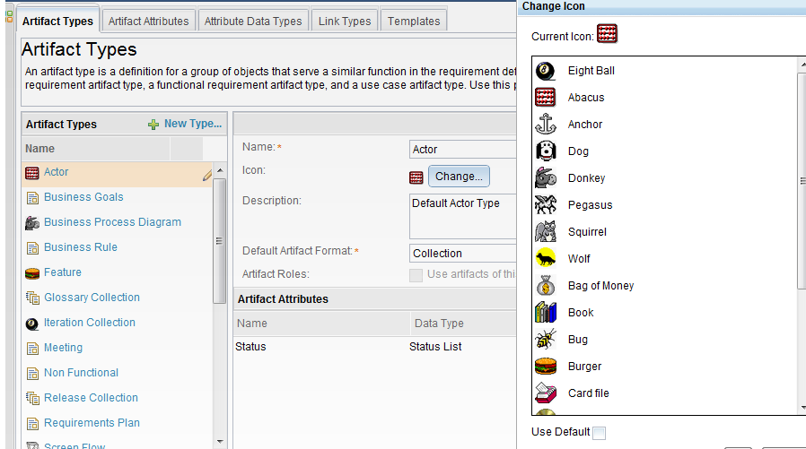
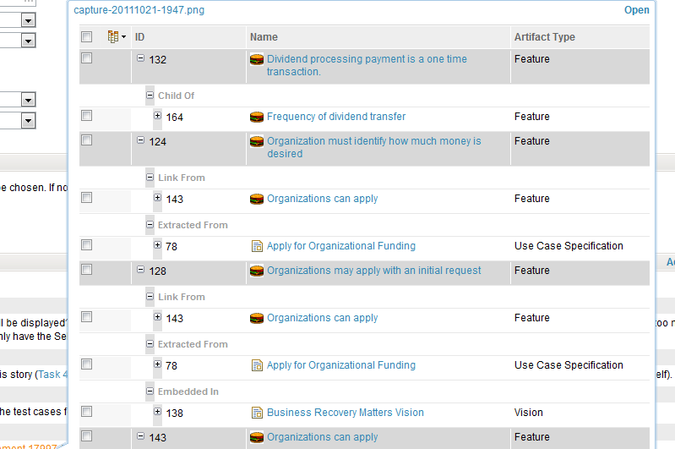

Multi-Value Attributes (MVA)
Attribute definitions can now be converted from single to multi-valued, and vice versa. It is always possible to convert from single to multi-valued, but multi-valued to single will be disallowed if there are any artifacts with multiple values for that attribute. Offending artifacts will be listed so they can be manually corrected.

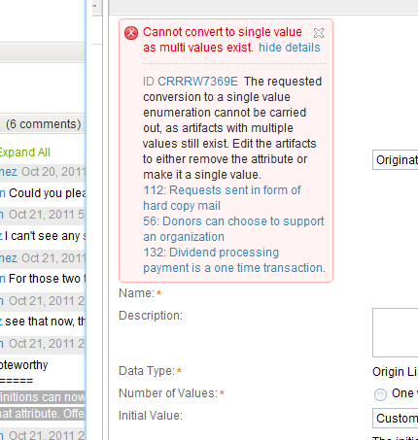

Modules

Module Editor
Prototype of a module "fisheye" has ben completed. Fisheye is a little box that tracks the scrollbar, showing the user the requirement they will land on should they stop scrolling at any given point. The fisheye constantly updates with information about the location in the overall module structure and gives the user an impression of where they are in the overall document as well as the requirement that will be in the viewport if they stop scrolling.
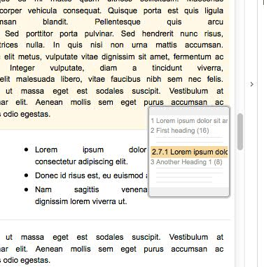

We have fixed the issues we had in M3 with new requirements, and newly created artifacts in the module now appear in the correct place: before, after, or as the last child. A new "Section" column is added to the module viewer that displays paragraph number for every requirement
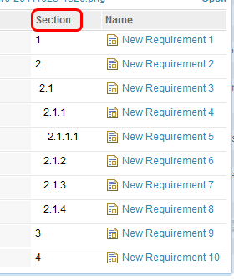

Inside of a module, member artifacts can be modified quickly in the context by selecting the appropriate section, making changes, and proceeding to modify other parts of the module. Changing focus to other parts of the module will immediately save any changes made.

Module Structure
Artifacts that are inside of a module can be re-ordered via cut & paste operations. These operations are performed in the context menu with artifacts selected in a module.
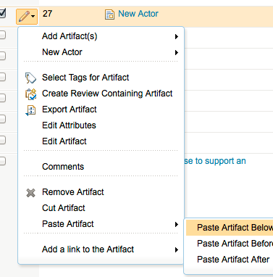
Following a structural modification, the grid is able to reconcile itself with a "page model". e.g. where the user is viewing the start of a module which comprises the first 30 artifacts, they may see section 1 (15 artifacts) then the start of section 2 (100 artifacts) they will only be able to see the first 15 artifacts of section 2. If they were to delete section 2 then all it's children would also be deleted and what was section 3 will be renumbered as 2 and should appear where 2 previously was. The grid is able to request the missing artifacts and then resize to take account of this change and virtual scrolling will work as normal.

Commenting, Tagging and Linking in the Context of a Module
Commenting on artifacts in the context of a module is enabled. A separate dialog with the artifacts' comments is opened. Currently, the comments are not contextual (i.e., all comments for the artifact will be listed vs. only comments made for the artifact in the context of the module). Contextual commenting for module artifacts will be implemented for M5.
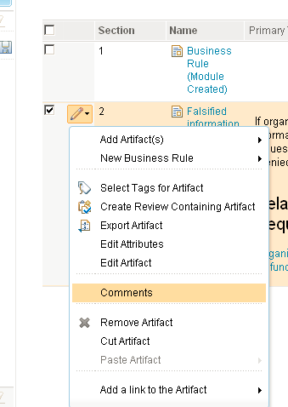
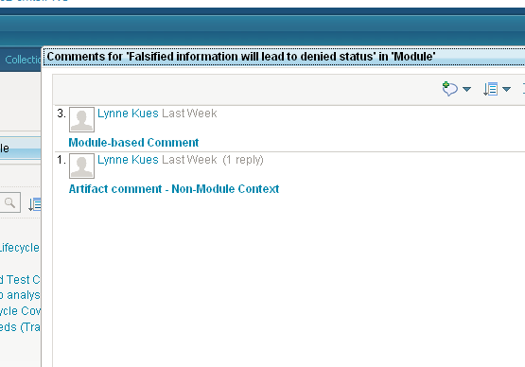
Tagging and linking from a requirement in the context of a module is now supported in M4. The following image shows the reused requirement and the core requirement, with different comments and links.
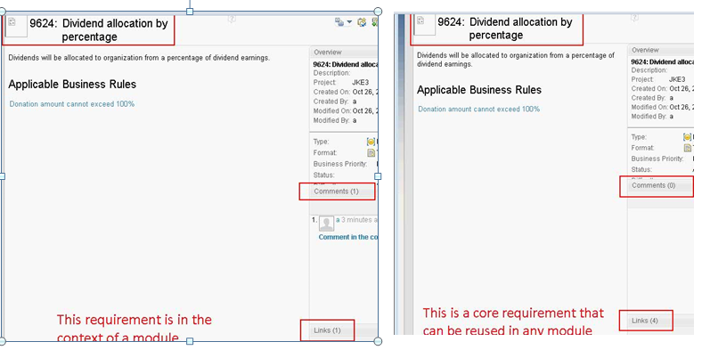

Fine Grained Write Access Control
Process permissions may be configured for each project area or for individual team areas. The operations which may be configured include saving artifacts, saving folders, saving links and saving team security. The save artifact and save link operations include project-specific actions, which allow permissions to be configured by artifact type and artifact attribute. Currently, permissions are only enforced for creating and deleting artifacts.
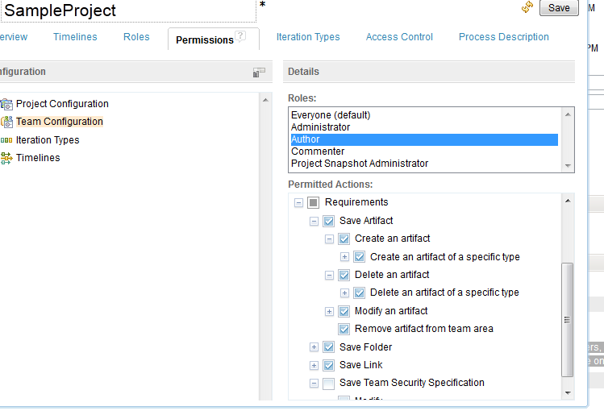
The context menu associated with each folder in the "Filter by Folder" filter section now contains a new "Manage Security" menu item. Invoking this action results in bringing up a new dialog in which you select the "process area" ownership for this folder. The "process area" can be set to either the project or to a team area associated with the project. You can configure Create and Delete permissions for each artifact type by Team Area (or the entire project). You can then associate a folder with a particular team area (or the project) to control which users can create or delete artifacts. When using this dialog you can optionally push this ownership change down to sub-folders as well.
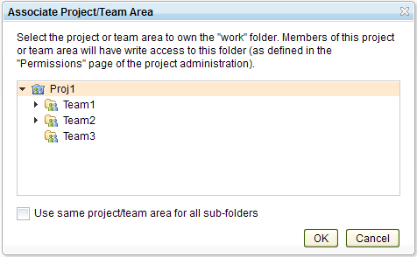

ReqIF Import
Req IF Import will allow a user to import a Req IF package file that has been exported from a Doors 9.4 instance into a RRC web client project as new resources. The user will be able to upload a package file and then import immediately, or come back later and choose a previously uploaded package for import.
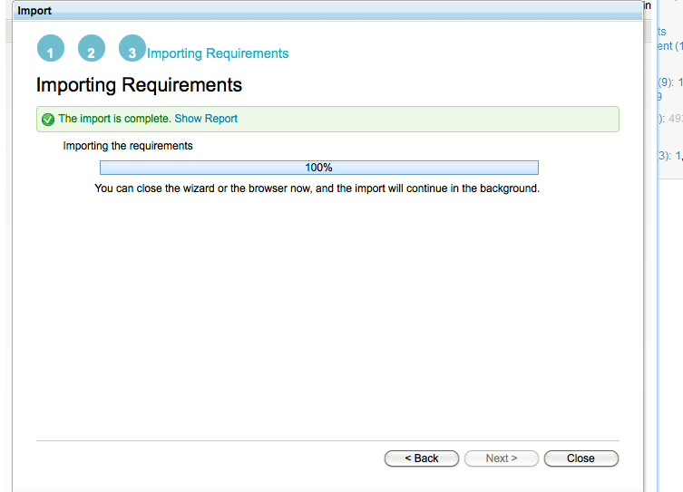
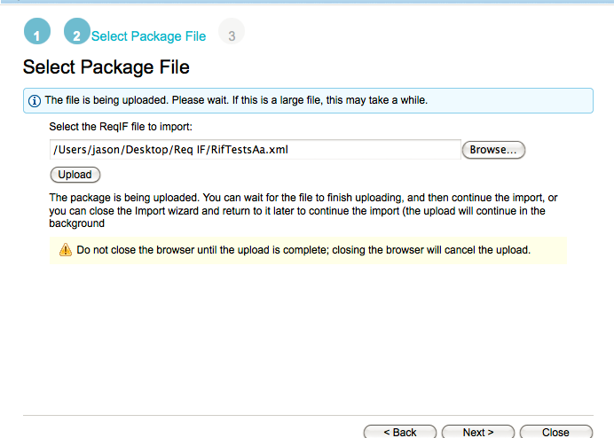

Accessibility

Filter Section:
The filter sections that appear on the left in the All Artifacts view are now keyboard navigable. For example, if focus is on a filter header, using Up/Left or Down/Right arrow keys will result in moving focus to the next filter section header. Clicking on Home or End will move to the first or last filter section and clicking on Space or Enter will toggle a filter between the collapsed and expanded states. Similar key mappings are found within the UI controls found in the content areas of these filters (e.g. you can use Down arrow to move from "Name" to "Artifact Type" in the "Filter by Attribute" filter section).
UI controls that are thought of as "list boxes" (e.g. "Artifact Type") contain a single tab stop; you must use Up and Down arrows to navigate among the separate entries. In general, clicking on Tab brings you to the next focusable element and clicking on Shift-Tab brings you to the previous focusable element.
In addition, these filter sections now contain appropriate DOM node changes to support ARIA role and property settings for screen readers.

Graphical Artifacts (RRCx)
Graphical artifacts can now be viewed in high contrast mode. The following images are before (left) and after (right) we started to support high contrast mode.
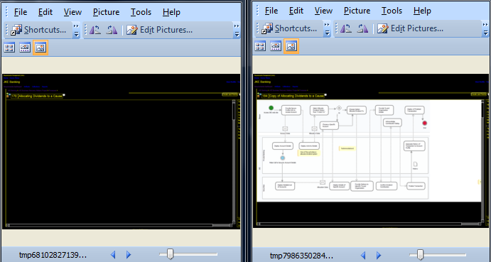

Keyboard navigation for graphical artifacts has also been improved. This includes improvements in navigation to and from the editor and context toolbars. From within the context of a graphical artifact, you can navigate to either the context toolbar or the editor toolbar. From these toolbars you can also navigate back into the graphical artifact.

Splitter
Sidebar splitters are focusable and can be sized via the keyboard right/left arrow keys. The splitter toggle button operates with Space key when it has focus. Home/End keys can be used to minimize and maximize the sidebar areas.

Links Explorer
A new option shows up in the main appearance menu allowing the user to enable "quick create mode". Enabling this feature causes a dialog to appear, which prompts the user for default link type, artifact type, and directory. Once this is chosen, the user can click the "add link" icon on the toolbar of the tree nodes to create a new blank artifact, which is represented through a tree node that is in edit mode. This allows for quick creation of new artifacts through Links Explorer.
One if the goals behind this quick create mode was to have the feeling of a Mind Map like experience, to quickly create and breakdown requirement with one click.
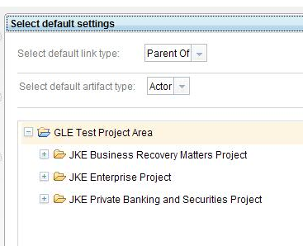

CSV Import and Requirements Parsing (from Word)
You can now import a CSV requirements file into a Module. The M4 build allows (1) importing requirements into a folder, (2) importing requirements in to a module, (3) importing module bindings into a folder, and (4) importing module bindings into a module.
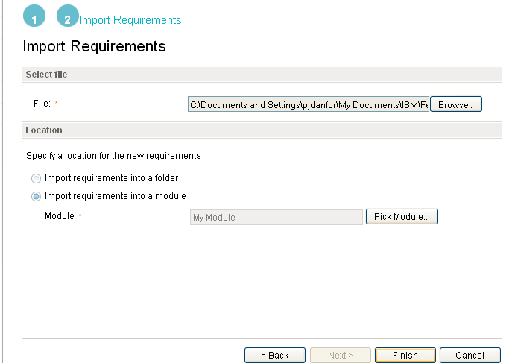

There is now the ability to import and parse a convertible document (Word, Open Document, or Rich Text Format) into requirements. These requirements can target either a folder or a new Module in the folder you specify.
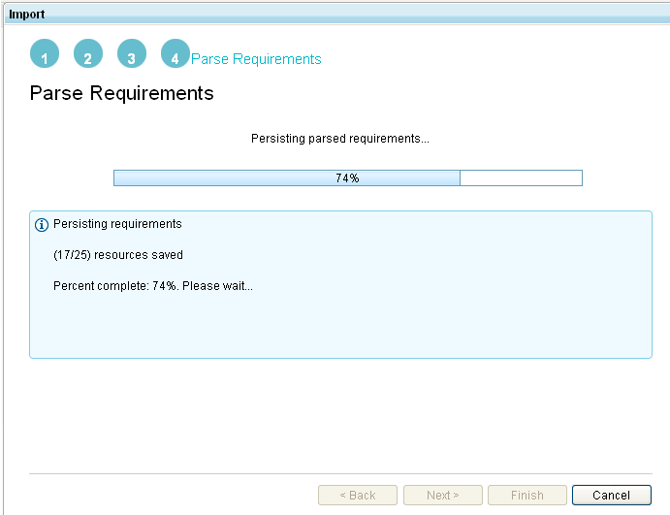
You must specify the way in which you would like for the requirements to be parsed from the document. Note that for M4 the only option is to parse requirements by headings. For the release, you will also be able to parse requirements based on keyword and delimiters. Artifact types must be specified for both requirements and non-requirements that will be parsed. Detailed progress is shown while the requirements are being parsed and stored on the server.

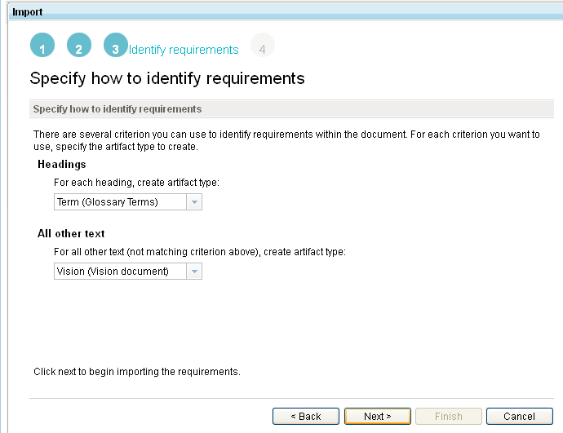

Support for upgrade from 3.0.1.1 and 3.5M3 to 3.5 M4
Support is added for the upgrade of RRC from version 3.0.1.1 and 3.5M3 to 3.5M4. Details of which can be found at https://jazz.net/wiki/bin/view/Main/CLM3NextMilestoneUpgradeM4.

Usability Improvements
Artifact selection picker now remembers last project and folder selected. The picker will populate last project and folder(s) selections upon start.

