Build Update Guide
RQM 4.0 WAS ND Cluster Environment

Version: 1.1
Date: 2012/2/15
Author: David
(Xin Peng Liu/China/IBM)

Document History

Document Location
This is a snapshot of an on-line document. Paper copies are valid only on the day they are printed. Refer to the author if you are in any doubt about the currency of this document.

Revision History
Date of this revision: | Date of next revision (date)

Revision Number | Revision Date | Summary of Changes | Changes marked
1.0 | (2011-11-14) | David created the first draft | (N)
1.1 | (2012-02-15) | David update points for RM and LPA app property change | (N)

Approvals
This document requires following approvals. Signed approval forms are filed in the Quality section of the PCB.
Name | Title
(name) | (title)

Distribution
This document has been distributed to
Error: Reference source not found | Error: Reference source not found
(name) | (title)
Contents
Document History 2
Document Location 2
Revision History 2
Approvals 2
Distribution 2
1. WebSphere Application Server Update 3
2. DB2 Update 4
3. Rational CLM Solution Update 4

WebSphere Application Server Update
      - Make sure you have 2 member servers in the cluster started up so that the following changes performed could be reflected in all nodes.
      - From deployment manager admin console, uninstall all the 7 war files and save to master configurations. The saving will be replicated to all nodes.
Perform following steps after you finish all the steps in section 3:
      - Start 2 member servers in the cluster if they are stopped in former steps.
      - Follow step 18-31 in section 4.5.4 of installation guide to deploy and configure the 7 applications again using deployment manager admin console.
Note: In step 30, please make sure the applications are deployed onto 2 servers (if you follow section 4.5.7 in the installation guide and have a WebSphere Cluster installed, you can just map these applications to that single cluster).
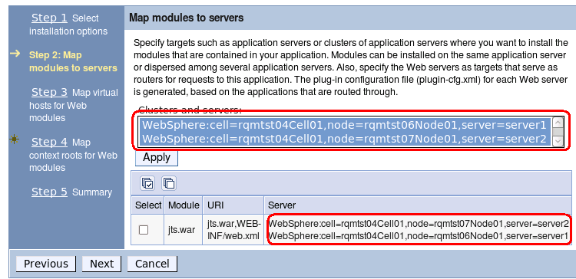
      - Follow step 1-6 in section 4.5.6 of installation guide to change the team server property file content for JTS, CCM, QM, RM and LPA applications in VM II (Or if you have some backup file, just simply restore them).
      - Follow step 9-11 in section 4.5.6 of installation guide to create databases contents for JTS, CCM and QM from VM II.
      - Copy whole “/opt/IBM/JazzTeamServer” folder from VM II to VM III with the same folder path.
      - Stop server 2, and restart server 1 from deployment manager’s admin console. It is suggested to clear all the files in “wstemp” and “temp” folders under the server 1 and server 2’s root profile folder when servers are stopped. We will setup CLM applications first in the node at VM III.
      - Follow step 14-30 in section 4.5.6 of installation guide to setup CLM applications (make sure you have the proxy server started beforehand).
      - Copy whole “/opt/IBM/JazzTeamServer” folder from VM III to VM IV with the same folder path.
      - Start server 2. The CLM application will be updated successfully in the cluster environment.

DB2 Update
- Make sure you have finished step 1-2 of section 1 before you shut down databases and perform following steps, in case some db connections are still alive.
- Drop databases using below commands using user db2inst1 from VM I where db2 is installed:
  - db2 drop database JTS
  - db2 drop database CCM
  - db2 drop database QM
  - db2 drop database DW
- Remove all the files in the folder “/home/db2inst1/db2inst1/NODE0000/jazzdw”.
- Repeat step 3-6 in section 3.1.3 of the installation guide.

Rational CLM Solution Update
- Make sure you have all the steps in section 2 finished before come to steps below.
- (Optional) You may want to backup existing CLM installation. To achieve this, from VM II where deployment manager profile is installed, you may copy and rename folder “/opt/IBM/JazzTeamServer”, e.g., to “/opt/IBM/JazzTeamServer-20111114”.
- Uninstall Rational CLM Solution using IBM installation manager.
- When finished, make sure folder “/opt/IBM/JazzTeamServer” is removed. Or you can remove it manually.
- For VM III and VM IV, you may optionally repeat step 2 to do backup. Shut down the 2 servers on the cluster nodes from deployment manager’s admin console of VM II, and remove folder “/opt/IBM/JazzTeamServer”.
- Install Rational CLM Solution using IBM installation manager following section 4.5.2 in installation guide.

