Common Reporting with Custom Attributes in RQM RC0
V1, 2010/10/14, by Peter Haumer, phaumer@us.ibm.com
Create a custom attribute and write down the name and type of the attribute 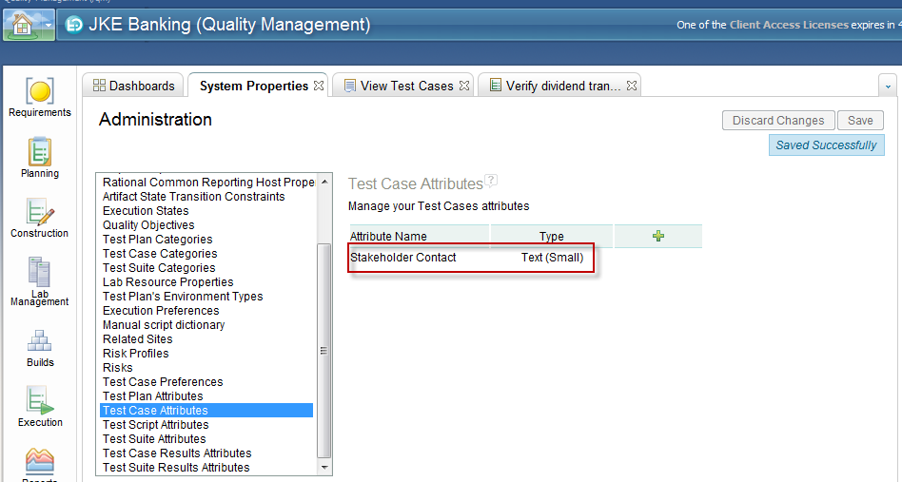
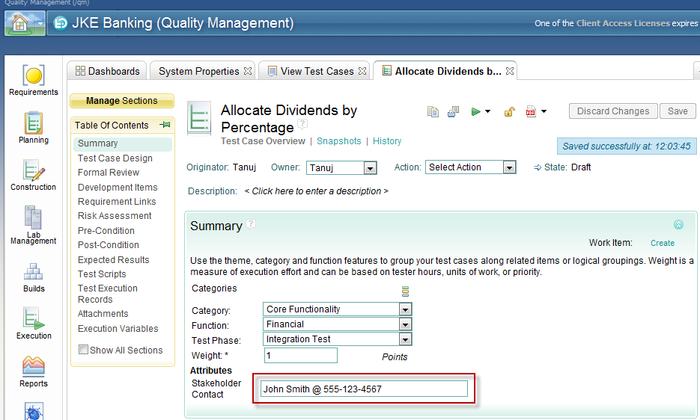
Run the ETLs

Copy a report that you want to modify in Common Reporting
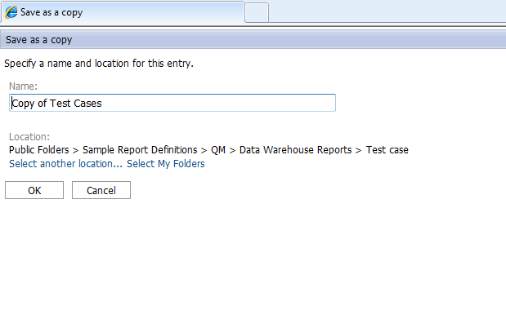
Open the copied report in Report Studio
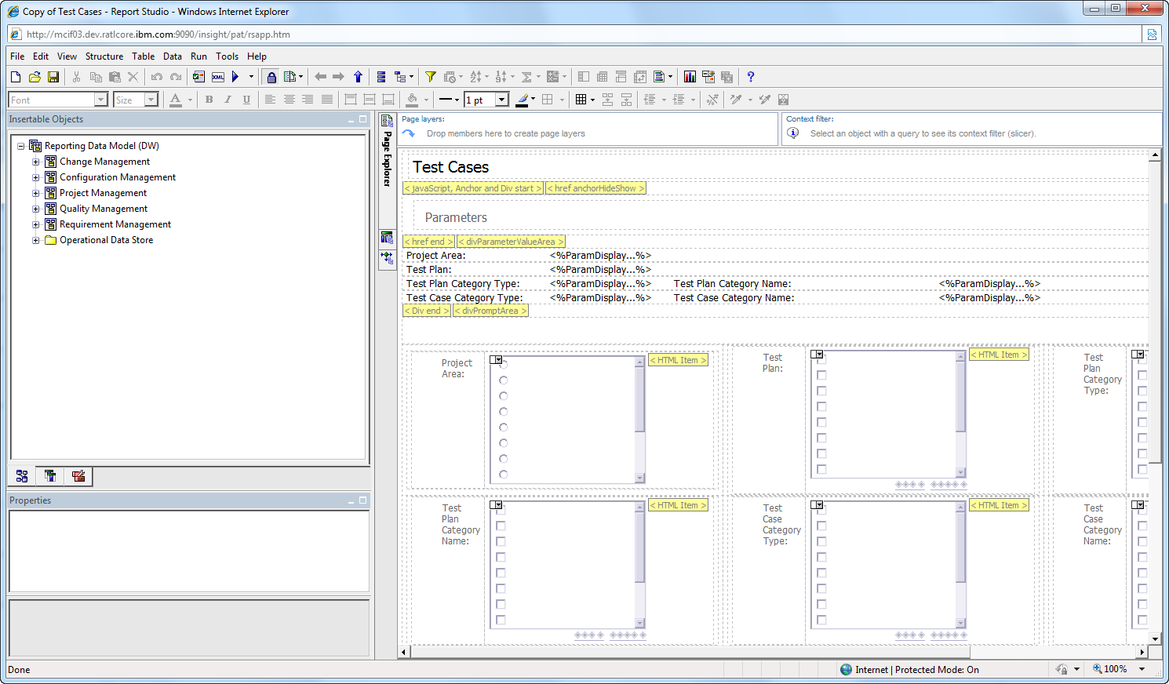

Modify all the queries and joins for the report to include custom attributes
Add custom attributes from the Operation Data Store folder. For example, find the test case custom attributes in the the Test Case Area sub-folder. There are specific query subjects for each possible custom attribute datatype such as “Test Case String Extension” or “Test Case Integer Extension”.
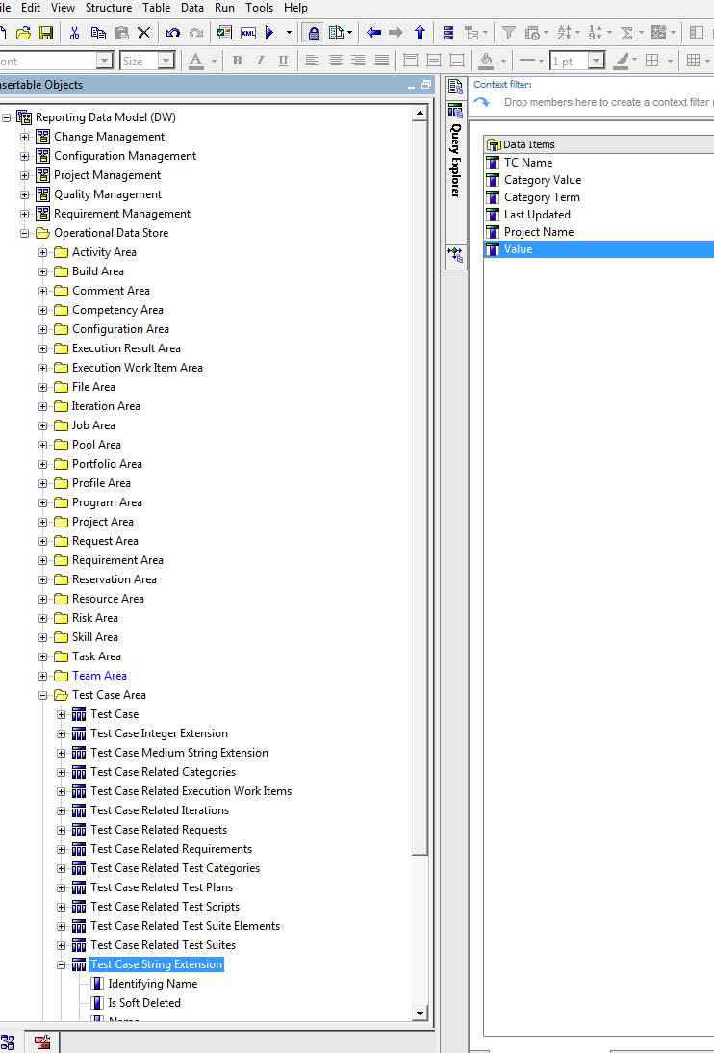
Add the Value attribute of the right query subject which represents your custom attribute type (e.g. “Test Case String Extension”, which is called “Text (Small)” in the RQM UI.)
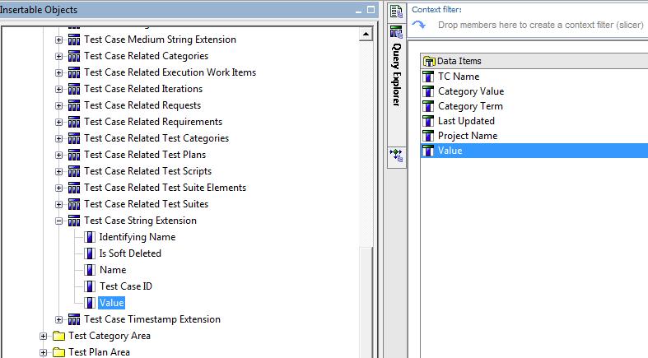
Rename the dragged attribute to reflect the custom attribute name
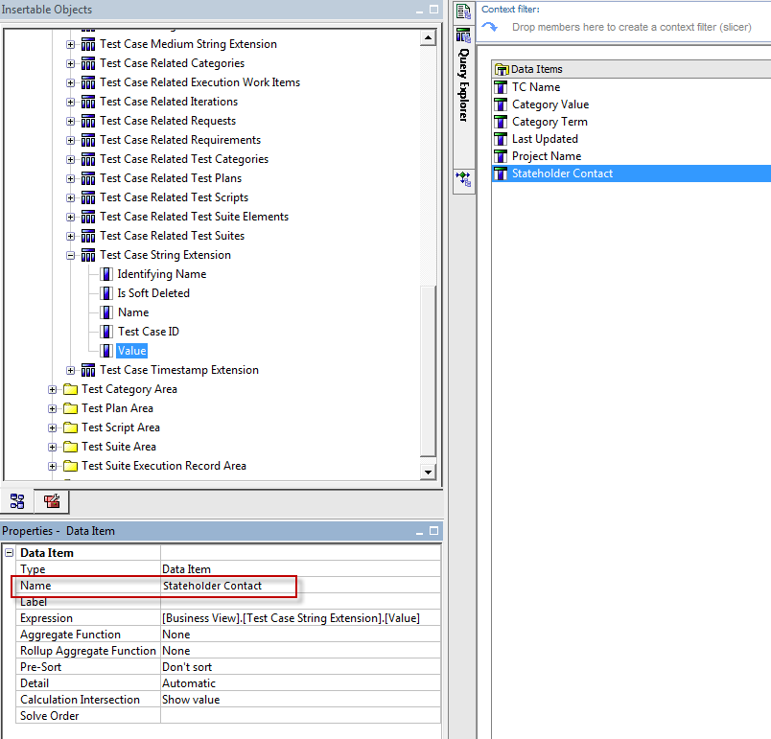
Drag in the Name attribute of the same query subject and rename it to Custom Attribute Name
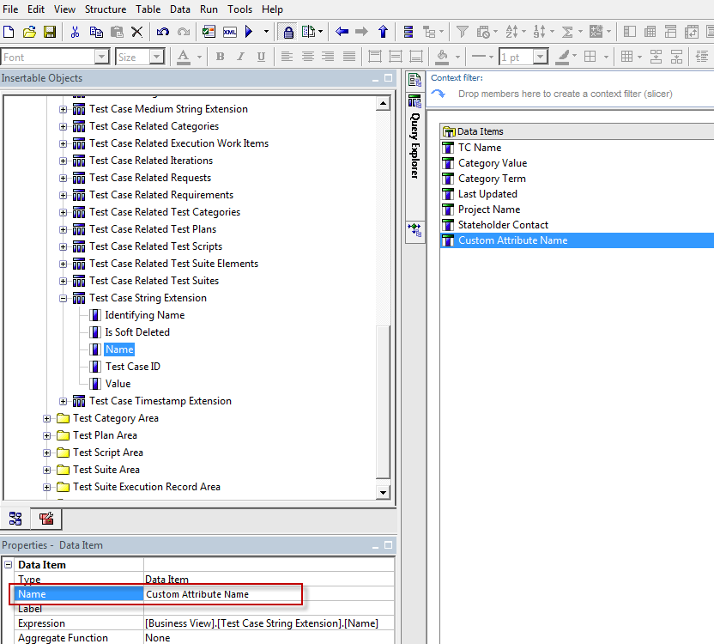
Select the custom attribute (former Value attribute renamed to Stakeholder Contact in this example) and edit its expression to filter out all values if the Custom Attribute Name does not match (Stakeholder Contact).
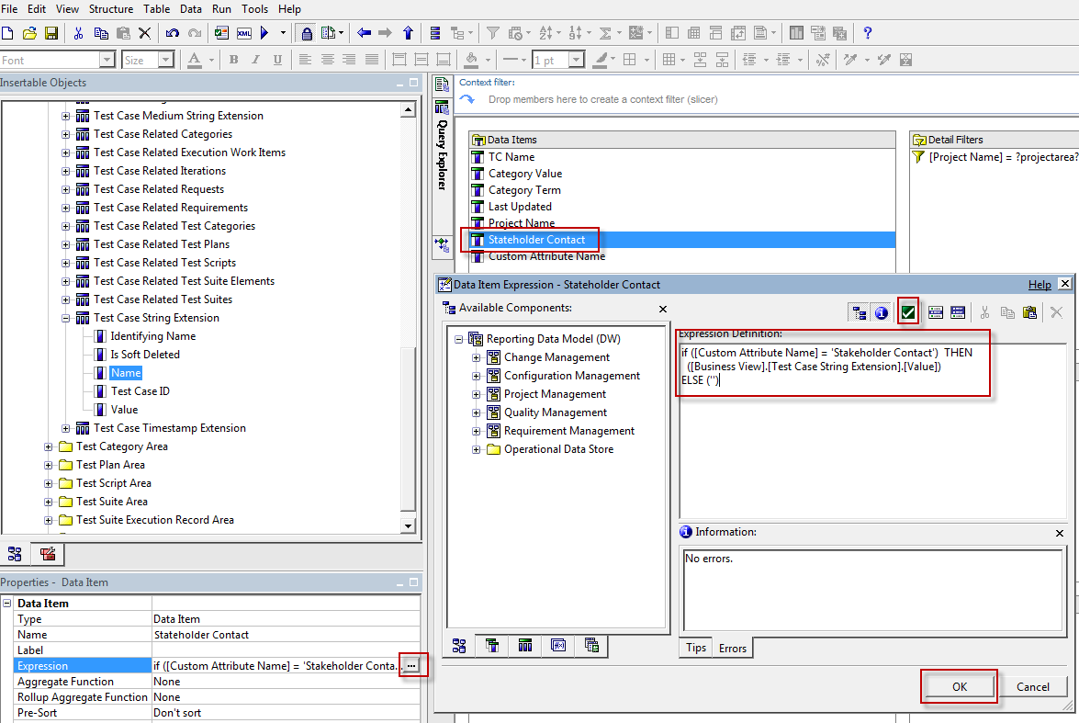
For example,
if ([Custom Attribute Name] = 'Stakeholder Contact') THEN
([Business View].[Test Case String Extension].[Value])
ELSE ('')
This is not necessary for simple reports, but if your query is used in joins make sure to drag your new attributes into those as well. If that join is used as well then transitively also update all parents.
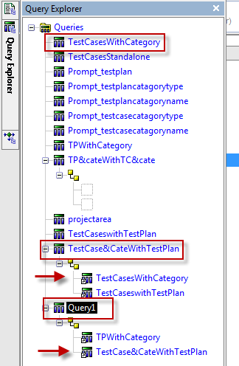
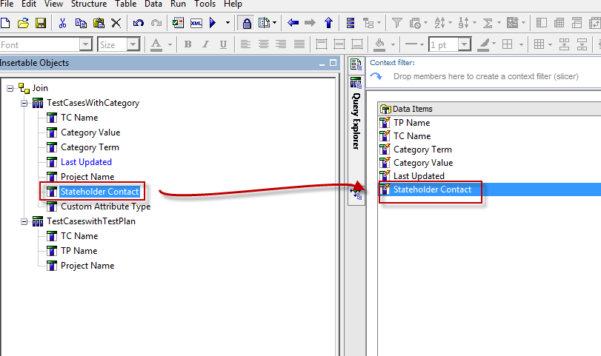

Finally, drag the new attribute into your report
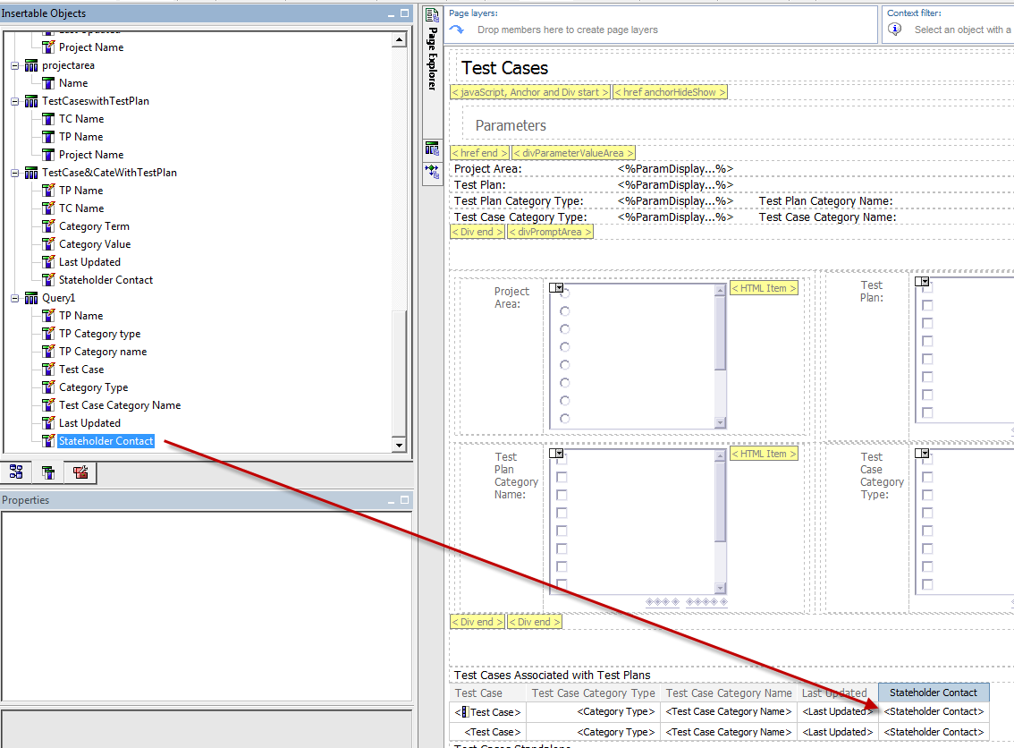
Then run the report to see your custom attribute (not shown here: adjust group span and styles of the new column)
