How do I unlock or Reset a PW in PWM

Resetting a Password or Unlocking a User in PWM LDAP
What is needed:
1. PWM URL
2. Login / Password Information .
3. User name that needs verification

- Login into the PWM site for the customer in question with Jazz Admin login and Password
<customer public uri >/pwm

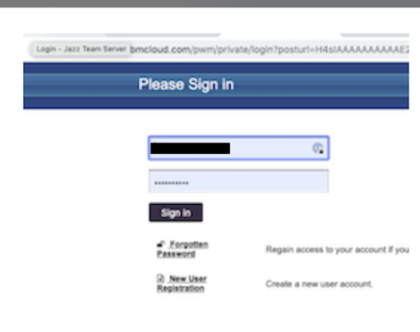

- Once you log in, select User Administration on lower left side of the PWM Dashboard:
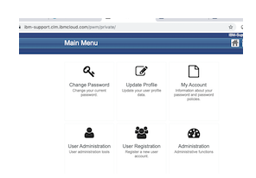

- Enter the first letter of the name of the user (Enter more characters if needed) Then click on the user you need to verify / change.
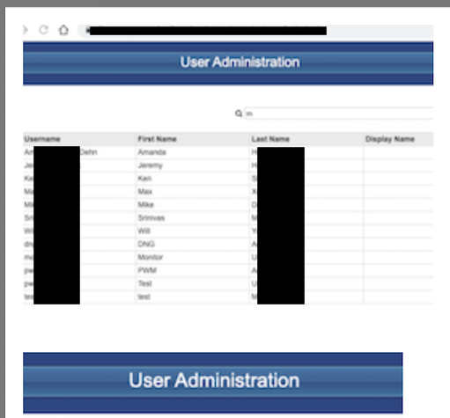
- On the right side of the page, select either "Unlock" or Reset Password.
- Password resets should be done with the user on the phone. You can create a simple password for them, but have them immediately log in and change it.
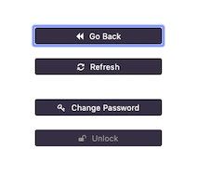
Click Update User to save
- In the top right, click the arrow to logout.
