Amy Silberbauer

safeinfo@bg.vnet.ibm.com

Abstract

This document describes the set of reports available for your scaled agile tooling environment, how to import them into your environment, and the best practices for deploying those reports as widgets on your CLM application dashboard(s).

Enterprise Scaled Agile Reporting Guidelines

Contents

Enterprise Scaled Agile Reports Overview 2

Assumption & Limitations 4

Archive Files 5

How do I choose which reports to use? 5

Import the Reports 7

Step 1: Prepare Tooling Environment 7

Step 2: Refresh Report Builder Data Source Metadata 8

Step 3: Import the Reports 9

Appendix A: Reports Catalogs 12

DB2 Advanced SQL Reports – 6.0.6 12

Enterprise Scaled Agile Reports - 6.0.6 19

SAFe 4.5 Reports - 6.0.6 22

Appendix B: Troubleshooting 30

Missing Metadata 30

Improperly Configured Tooling 31

You are using a Data Warehouse that is not based on DB2 31

You have not created the necessary project area(s) in RTC 31

You are using RTC only (not RDNG or RQM) 34

# Enterprise Scaled Agile Reports Overview

**Last Update:** Thursday, December 20, 2018

Change History:

|  |  |  |
| --- | --- | --- |
| 2018-12-20 | Updated all reports for the 6.0.6 and 6.0.6.1 environments, creating three separate archives:   * DB2 Advanced SQL Reports – 6.0.6 * Enterprise Scaled Agile Reports – 6.0.6 * SAFe 4.5 Reports – 6.0.6   The Team and Program Burn-Up and Burn-Down Charts have been replaced by Sprint and PI Burnup and Burndown Charts, respectively.  Included an Advanced SQL utility report: Project & Iteration IDs | |
| 2018-10-23 | Separated out the 4 DB2-specific Advanced SQL reports from the rest of the archives so that errors would not occur on import in non-DB2 environments | |
| The following reports contact DB2-specific SQL syntax and have been moved out of the other archives until this is resolved   * Portfolio Epic Burn-Up Chart (FULL SAFe) [Advanced SQL] * Portfolio Epic Burn-Up Chart (PORTFOLIO SAFe) [Advanced SQL] * Solution Epic Burn-Up Chart [Advanced SQL] * Team Burn-Down Chart (by Story Points) [Advanced SQL] | |
| 2018-08-01 | * Updated syntax in Advanced SQL reports that include POSSTR to change it to the more generic INSTR function, enabling support for both DB2 and Oracle. * Added a Capability Progress Measure – Specific PIs [Advanced SQL] report | |
| 2018-07-18 | Clarified that the Advanced SQL reports were developed for DB2 and highlighted some potential SQL syntax issues in an Oracle environment. | |
| 2018-06-01 | Updated the reporting archives with some of the more advanced reports | |
| New **Enterprise Scaled Agile** Reports:   * Approval Audit Trail * Days in State (by Month) * Defect Days in Current State * Estimated vs Actual Hours * Program Average Velocity [Advanced SQL] * Program Burn-Down Chart (by Story Points) [Advanced SQL] * Program Burn-Up Chart (by Story Points) [Advanced SQL] * Story Cumulative Flow Diagram * Team Average Velocity [Advanced SQL] * Team Burn-Down Chart (by Story Points) [Advanced SQL] * Work Item Cycle Time (by PI) | New **SAFe 4.5** Reports:   * Capability Cumulative Flow Diagram * Feature Cumulative Flow Diagram * Feature Progress by Team – Specific PI [Advanced SQL] * Portfolio Epic Burn-Up Chart (FULL SAFe) [Advanced SQL] * Portfolio Epic Burn-Up Chart (PORTFOLIO SAFe) [Advanced SQL] * Solution Epic Burn-Up Chart [Advanced SQL] |
| Moved the tables to the Appendix and added link to spreadsheet that summarizes the set of reports with categorization to more easily locate those of interest. | |
| 2018-02-23 | Changed the reporting archive names to ease import and rename of “tags” | |
| 2018-02-22 | Refresh of SAFe 4.5 and Enterprise Scaled Agile reports | |
| 2017-12-15 | First revision (Enterprise, Essential, Portfolio Reports) | |



This document describes the set of Jazz Reporting Service (JRS) reports developed to support Enterprise Scaled Agile processes and metrics, including those prescribed by the Scaled Agile Framework® (SAFe®). Details provided include:

* How to import the reports into an existing CLM environment
* The archive files provided and which reports they contain
* A detailed description of the reports, including applicable filters
* Troubleshooting information

## Assumption & Limitations

The reports provided align with specific releases and domain models. Some of them require use of the SAFe 4.5 templates, but not all of them.

* **Release:** All of the reports were developed and tested in a JRS 6.0.6 GA environment as well as a 6.0.6.1 milestone environment, so they will work in 6.0.6 or later. In many cases, they can be used in earlier releases.
* **Domain Model:** The reports are developed using the [Enterprise Scaled Agile Domain Models](https://www.ibm.com/developerworks/community/files/app#/file/61797b04-cd98-4f56-ba2a-6911c03b3a10) to define traceability across artifacts. If your domain models differ, you will need to import and then copy/edit the reports to match your model.
* **SAFe Dependency**: Many of the reports assume that SAFe 4.5 artifacts and attributes are in place in your environment, either through use of the SAFe 4.5 templates or through manual configuration. These are clearly captured separately in the *SAFe 4.5 Reports* archive file.
* **Advanced SQL**: In some cases, the reports are developed using Advanced SQL rather than Report Builder native features. We try to use basic SQL that is not specific to DB2, but there are some exceptions. The following Advanced SQL reports will not import successfully into environments where a third-party database vendor tool is used for the Report Builder relational data warehouse:
* **Portfolio Epic Burnup Chart [FULL SAFe]**
* **Portfolio Epic Burnup Chart [PORTFOLIO SAFe]**
* **Program Average Velocity**
* **Solution Epic Burnup Chart**
* **Team Average Velocity**

The SQL for these reports are provided on the [SAFe Reporting](https://www.ibm.com/developerworks/community/wikis/home?lang=en#!/wiki/W54ecb028c53d_48b0_9d5e_4584a00489d3/page/SAFe%20Reporting) download page so that, should you be using a third-party DB vendor tool, you can modify the DB2-specific SQL for these reports to suit your vendor’s specifications.

## Archive Files

Table 1: Report Archive Descriptions below describes the archive files delivered and what they contain at a high level.

|  |  |  |
| --- | --- | --- |
| Archive File | Purpose | |
| DB2 Advanced SQL Reports – 6.0.6 | These reports are developed with Advanced SQL based on a DB2 data warehouse. Most will successfully import and run in non-DB2 data warehouse environments. The ones that will not are highlighted above in the **Assumptions & Limitations** section. All of the SQL used to create the Advanced SQL reports is provided so you create your own versions of these if they will not import into your non-DB2 Data Warehouse environment. |
| Enterprise Scaled Agile Reports - 6.0.6 | These reports do not depend on SAFe or use of SAFe templates. Some of the reports expect that Story Points are used for estimating effort/complexity. In many cases, the work item type is *generic,* allowing you to use filters to indicate work item types and scope. | |
| SAFe 4.5 Reports - 6.0.6 | These reports support the four configurations of SAFe 4.5: Essential, Portfolio, Large Solution, and Full. Some of the reports assume a full CLM configuration for SAFe that includes Rational DOORS Next Generation (RDNG), Rational Quality Manager (RQM) and Rational Team Concert (RTC). The majority can be used in an RTC-only SAFe-based environment. Dependencies on the SAFe templates are due to certain artifacts and attributes assumed to be in place. | |

Table : Report Archive Descriptions

**Appendix A: Reports Catalogs** provides the set of reports in each archive, along with how you might set filters.

## How do I choose which reports to use?

The [Enterprise Scaled Agile Reports](https://www.ibm.com/developerworks/community/files/app#/file/204076da-d171-4ef2-8d9f-30c97f819e58)spreadsheet is a separate document that provides a list of all the reports, with additional details to help you decide which archive files to import and which reports would be useful in your environment.

The spreadsheet identifies the following characteristics of each report:

* **Archive File** The file that contains the report (as above in Table 1: Report Archive Descriptions).
* **Functional Group**
  + **Progress/Status:** Used to determine the progress or status of work at any level
  + **Quality:** Measures functional quality or business value delivery by tracking defects or PI Objectives
  + **Productivity:** Shows various measures of productivity, such as velocity in terms of work item count or story points delivered, or progress against estimates over time
  + **End to End Traceability:** Includes both cross-domain reports that show break down of work from business strategy through execution as well as traceability from a higher level of planning to a lower level
  + **Process Improvement:** Includes trending reports that show improvements in delivery over time, including metrics related to value
  + **Governance:** Helps gauge various activities around process and delivery governance
* **Organizational Level**
  + **All:** Report provides insight across all organizational levels
  + **Portfolio:** Report provides insight across a Portfolio or Solution/Value Stream
  + **Program:** Report provides insight across a Program of Teams
  + **Team:** Report provides insight on a specific Team
* **Complexity**
  + **Basic:** Just what is needed to get started with scaled agile tracking and planning, to include reports for any level.
  + **Intermediate:** Assumes certain concepts are being used beyond the basic tracking and planning capabilities, which could be more advanced RTC capabilities, SAFe concepts or cross-domain planning are in play. As your maturity in scaling agile evolves, these reports are useful.
  + **Advanced:** Implies strong maturity in scaling agile across an enterprise, requiring cross-domain planning (CLM), Portfolio-level planning or advanced SAFe concepts such as use of PI Objectives, reliance on Kanban work flow, use of Estimated Story Points or Proposed attributes.

# Import the Reports

In this section, we describe how to successfully import the report archive files into your CLM environment. For expected issues, refer to **Appendix B: Troubleshooting**.

## Step 1: Prepare Tooling Environment

To import the reports successfully, you must have a relational data warehouse configured as a Data Source for use with Report Builder and you must at least have a correctly configured RTC application. A few of the reports do require a full CLM environment.

Choose one of the two options below to configure your tooling environment:

* **Configure Tooling for Enterprise Scaled Agile Reports:** The reports in this archive file can be used in both SAFe- and non-SAFe-based environments. If you **do not** want to adopt SAFe, you cannot use the SAFe 4.5 Reports archive, but you may be able to take advantage of some of the reports in the DB2 Advanced SQL Reports, though some do require the SAFe methodology be in place. If you **do** want to adopt SAFe, skip this option and simply follow the steps in the next section.

1. Create (or ensure that you already have) a Scrum-based RTC project area that includes the **Blocked** attribute in any work item type: 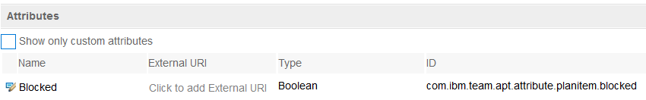

* **Configure Tooling for the DB2 Advanced SQL, Enterprise Scaled Agile and SAFe 4.5 Reports:** These reports are used in SAFe-based environments, which may include RTC only, or might also include RDNG and RQM. To ensure all reports are imported from this archive, follow these steps:

1. **[RTC]** Create (or ensure that you already have) both Portfolio-level and Essential SAFe 4.5-based RTC project areas. For the Portfolio level, use any of the three configurations for Portfolio: Full, Large Solution, Portfolio.
2. **[RDNG]** (optional) Create (or ensure that you already have) a SAFe 4.5-based project area that includes the **Value Stream Template** artifact. This means that you must configure Full, Portfolio or Large Solution SAFe – Essential SAFe does not include the **Value Stream Template** artifact.

**Notes:**

* No special configuration is required for **RQM.**
* **If you are using 6.0.5 or earlier**, import the SAFe 4.5 “beta” templates from the [SAFe® 4.5 Assets](https://www.ibm.com/developerworks/community/wikis/home?lang=en#!/wiki/W54ecb028c53d_48b0_9d5e_4584a00489d3/page/SAFe%C2%AE%204.5%20Assets) and create new SAFe-based project areas. Review [How to use the SAFe 4.5 templates in CLM.pdf](https://www.ibm.com/developerworks/community/files/app#/file/37b5df91-1c26-4191-b31b-b4250494cfc0) for further details. Ensure you have downloaded the latest versions of the “beta” templates.
* **If you are using 6.0.6 or later**, deploy the predefined templates for each application you have installed (RTC, RDNG, RQM) and create new SAFe-based project areas for Essential and Portfolio levels.
* **If you want to manually configure SAFe 4.5 in an existing environment**, refer to these guidelines:
  + **Scrum 🡪 SAFe 4.0:** [Configuring SAFe V4.0 in CLM (2016-08-17).pdf](https://www.ibm.com/developerworks/community/groups/service/html/communityview?communityUuid=c914709e-8097-4537-92ef-8982fc416138#fullpageWidgetId=Wedf911c66e55_4a99_b89e_1bbdb89a7919&file=7e4670c1-3c41-4781-9778-1258ca93f4fb)
  + **SAFe 4.0** 🡪 **SAFe 4.5:** [Configuring SAFe 4.5 in CLM.pdf](https://www.ibm.com/developerworks/community/files/app#/file/dde97292-cdf9-4535-bc44-00d0274991e9)

## Step 2: Refresh Report Builder Data Source Metadata

Now that your tooling environment is configured, you must run data collection to update the relational Data Warehouse and then refresh the Report Builder Data Source to capture the new metadata.

1. Run **ODS Data Collection** via the Data Collection application:
2. Launch DCC in your browser: https://<host>:<port>/dcc/web
3. In the **ODS Data Collection** section, click **Run**:

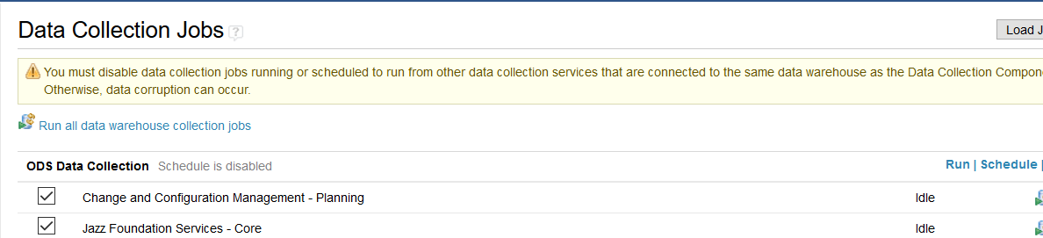

1. Ensure all jobs complete successfully
2. Refresh your JRS data warehouse Data Source:
3. Launch JRS in your browser: https://<host>:<port>/rs
4. Click the **Report Builder** menu drop-down, then **Admin**:

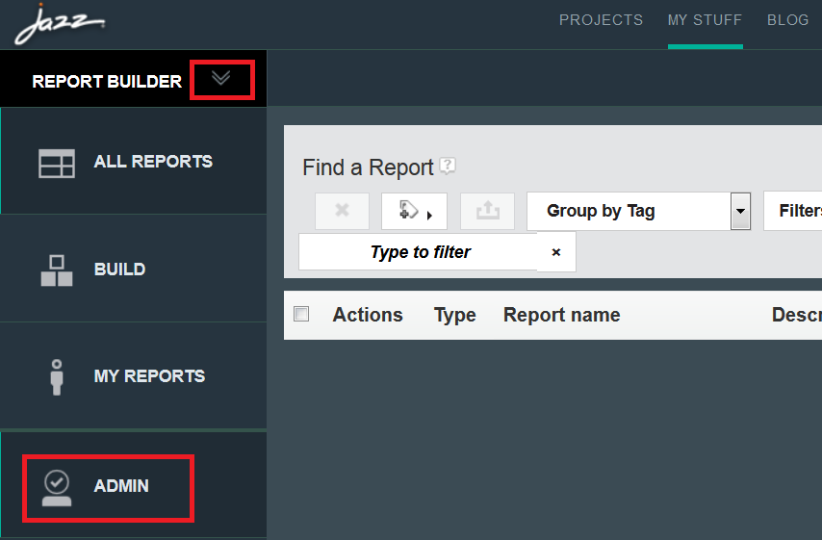

1. Click **Data Sources** and select the appropriate data source to refresh:

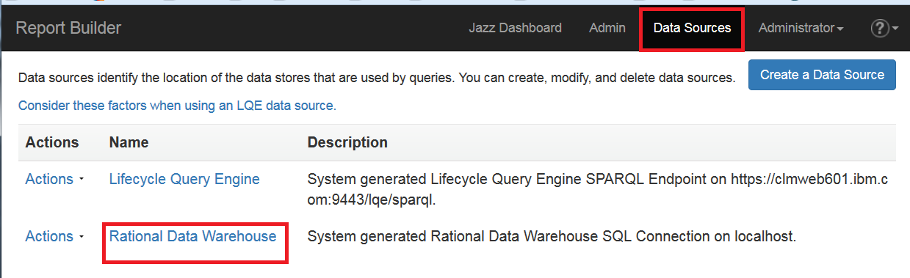

1. Edit the data warehouse data source and click **Refresh**:

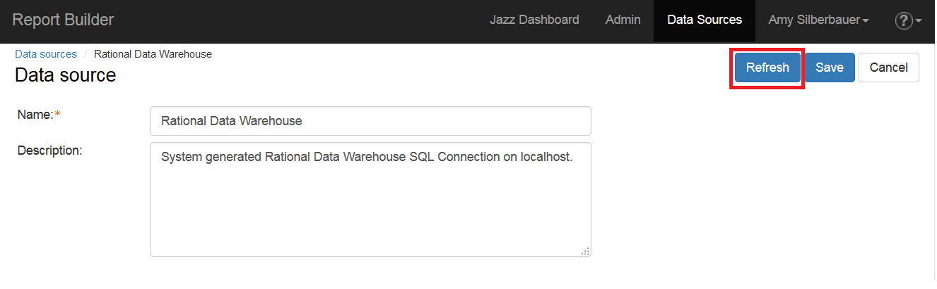

1. Save your changes.

## Step 3: Import the Reports

Download the reporting archives of interest to you and then import them into Report Builder following these steps.

1. In Report Builder, click **Admin** to go to the Report Builder Administration page and import one or more of the SAFe reports archive files:
2. In **Import ready-to-use reports**, select **Optional: Import additional reports such as those provided by IBM, business partners, or others**.
3. Browse to the location where you have downloaded the reporting archive files and select any one of them. Click OK.
4. Repeat this process to import the remaining archive files.

If you have followed all the steps above, your import(s) will be successful. Note that if there are any issues with specific reports. Report Builder will import those that it can and skip the ones with problems. Your results should look like these:

***DB2 Advanced Reports – 6.0.6***

If you are using a DB2 data warehouse, your results will look like this:

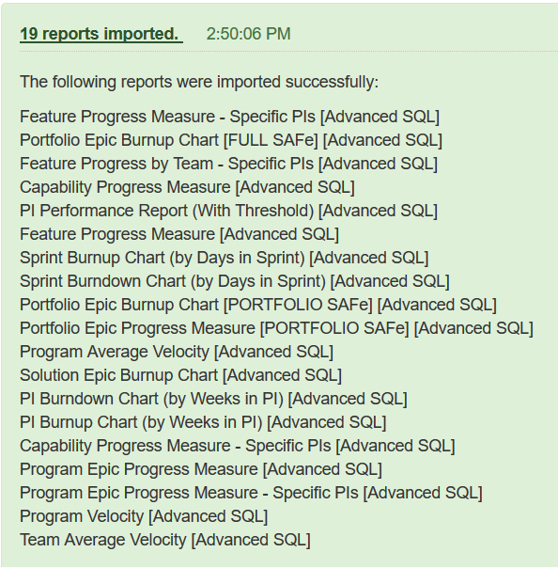

If you are not using a DB2 data warehouse, 14 reports will import successfully and 5 reports will be skipped, as explained above.

***Enterprise Scaled Agile Reports - 6.0.6***

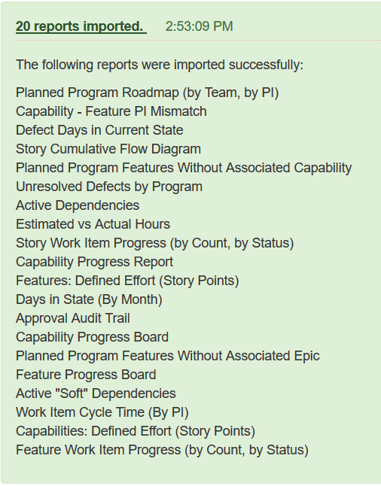

***SAFe 4.5 Reports - 6.0.5***

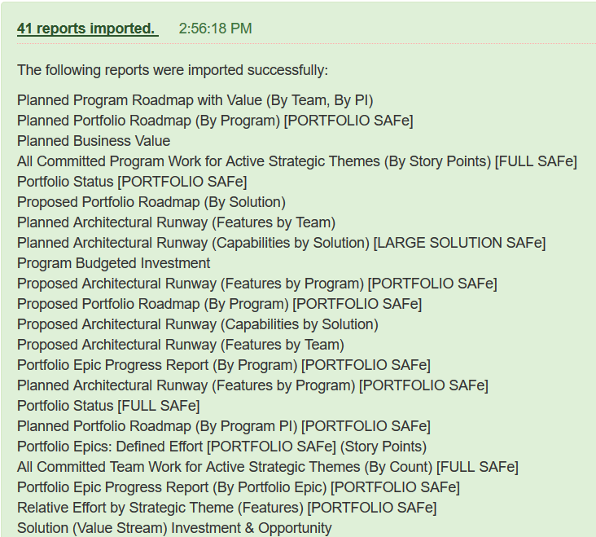

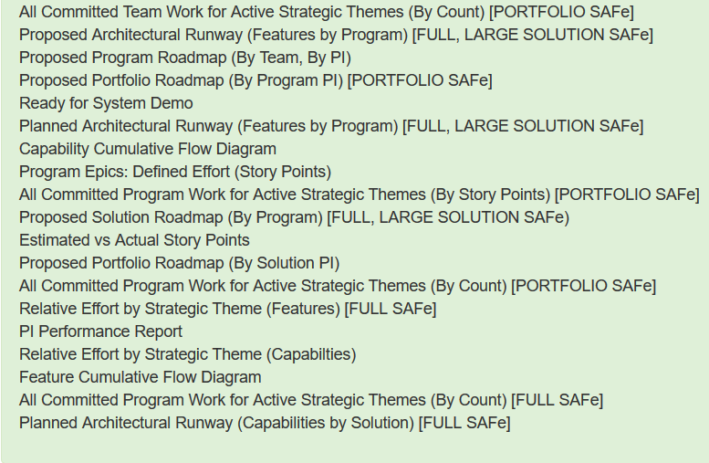

# Appendix A: Reports Catalogs

Each of the sections below provides information on the reports available, grouped by archive file, along with the filters that you might specify. For more detail on the reports, refer to the [Enterprise Scaled Agile Reports](https://www.ibm.com/developerworks/community/files/app#/file/204076da-d171-4ef2-8d9f-30c97f819e58) spreadsheet.

You cannot import a portion of an archive, but you do not need to import all of archives. If you do not have a complete, cross-domain Full SAFe environment, you may encounter warnings on import. This is completely fine and expected. Reports that cannot be imported in a given archived will be *skipped* and Report Builder will alert you to that with a list of skipped reports.

## DB2 Advanced SQL Reports – 6.0.6

**Table 2: DB2 Advanced SQL Reports** below describes the set of reports available, written using Advanced SQL for use with a DB2 data warehouse. Some reports require a SAFe-based tooling environment and/or DB2 for the Data Warehouse. This information is annotated.

**Note:** When running or editing these reports, you may see an error similar to the one below from Report Builder:



The report can be edited and run successfully, so the error can be ignored.

Table : DB2 Advanced SQL Reports

|  |  |  |  |  |
| --- | --- | --- | --- | --- |
| SAFe? | DB2? | Report | Description | Filters  [*Required in Boldface] |
|  |  | Project & Iteration IDs | This report is a utility that can be used to determine Project and Iteration IDs used in many of the reports in this table. | |
| X |  | **Capability Progress Measure – Specific PIs [Advanced SQL]** | The Capability Progress Measure provides an at-a-glance view of the status of Capabilities in a Solution/Value Stream. The report shows the story point estimates and actuals through the traversal from Capability > Feature > Story. It can be used for Full or Large Solution configurations. Use this version of the report to limit the PI scope. | 1. **Limit the scope of Project Areas included (RTC Portfolio, Program(s), Team(s))** 2. **Specify the Projects in scope (Portfolio, Solution(s), Program(s), Teams(s))** 3. **Specify the Capability PI filter (no wildcards)**   Examples:  **CapabilityPIFilter = PI 1** returns Capabilities planned for PI 1  **CapabilityPIFilter = PI** returns Capabilities planned for any iteration with “PI” in the name |
| X |  | **Capability Progress Measure [Advanced SQL]** | The Capability Progress Measure provides an at-a-glance view of the status of Capabilities in a Solution/Value Stream. The report shows the story point estimates and actuals through the traversal from Capability > Feature > Story. It can be used for Full or Large Solution configurations. | 1. **Limit the scope of Project Areas included (RTC Portfolio, Program(s), Team(s))** 2. **Specify the Projects in scope (Portfolio, Solution(s), Program(s), Teams(s))** |
| X |  | **Feature Progress Measure – Specific PIs [Advanced SQL]** | The Feature Progress Measure provides an at-a-glance view of the status of Features in a Program. The report shows the story point estimates and actuals through the traversal from Feature > Story. Use this version of the report to limit the PI scope. | 1. **Limit the scope of Project Areas included (RTC Program(s), Team(s))** 2. **Specify the Projects in scope (Solution(s), Program(s), Teams(s))** 3. **Specify the Feature PI filter (no wildcards)**   Examples:  **FeaturePIFilter = PI 1** returns Features planned for PI 1  **FeaturePIFilter = PI** returns Feature planned for any iteration with “PI” in the name |
| X |  | **Feature Progress Measure [Advanced SQL]** | The Feature Progress Measure provides an at-a-glance view of the status of Features in a Program. The report shows the story point estimates and actuals through the traversal from Feature > Story. | 1. **Limit the scope of Project Areas included (RTC Program(s), Team(s))** 2. **Specify the Projects in scope (Solution(s), Program(s), Teams(s))** |
| X |  | **Feature Progress Measure by Team – Specific PIs [Advanced SQL]** | The Feature Progress by Team report provides an at-a-glance view of the status of Features in a Program. The report shows the story point estimates and actuals through the traversal from Feature > Story grouped by Team. | 1. **Limit the scope of Project Areas included (RTC Program(s), Team(s))** 2. **Specify the Projects in scope (Solution(s), Program(s), Teams(s))** 3. Specify the Team(s) in scope 4. **Specify the Feature PI filter (no wildcards)**   Examples:  **FeaturePIFilter = PI 1** returns Features planned for PI 1  **FeaturePIFilter = PI** returns Feature planned for any iteration with “PI” in the name |
|  |  | **PI Burndown Chart (By Weeks in PI) [Advanced SQL]** | This report shows the burndown of Story Points (planned vs remaining) grouped by week in the specified iteration (PI) scope. All Teams contributing to the PI are in the scope of this report.  It does not require any specific process template, only the existence of Stories with Story Points. The default time interval is weeks within the PI. Edit the report to change the time interval if necessary. | 1. **Specify the ID of the Program PI**   **Hint:** Use the **Project & Iteration IDs** report to get a list of Program IDs.   1. Limit the scope of Project Areas included (RTC Program(s), Team(s)) |
|  |  | **PI Burnup Chart (By Weeks in PI) [Advanced SQL]** | This report shows the burnup of Story Points (planned vs closed) grouped by week in the specified iteration (PI) scope. All Teams contributing to the PI are in the scope of this report.  It does not require any specific process template, only the existence of Stories with Story Points. The default time interval is weeks within the PI. Edit the report to change the time interval if necessary. | 1. **Specify the ID of the Program PI**   **Hint:** Use the **Project & Iteration IDs** report to get a list of Program IDs.   1. Limit the scope of Project Areas included (RTC Program(s), Team(s)) |
| X |  | **PI Performance Report (With Threshold) [Advanced SQL]** | This report shows the average achieved value over time for the specified Solution, Program or Team scope, grouped by iteration. Best practice suggests that a range between 80% - 100% indicates release stability and is a measure of predictability over time. Teams that are wildly above or below that threshold are considered unpredictable. Copy this report and edit it to change the thresholds for your organizational standards. | 1. **Limit the scope of Project Areas included (RTC Portfolio, Program(s), Team(s))** 2. **Specify the Projects in scope (Portfolio, Solution(s), Program(s), Teams(s))** 3. **Specify the Team(s) in scope** 4. Specify the iteration(s) to include in scope |
| X |  | **Portfolio Epic Burnup Chart [FULL SAFe] [Advanced SQL]** | This report shows the burn-up of story points for a specific Portfolio Epic over time based on the Sprint cadence. You must specify project scope as well as the ID (or a comma-delimited list of IDs) for the Portfolio Epic you want to report on. This report is for a FULL SAFe environment: Portfolio Epic > Solution Epic > Capability > Feature > Story. | 1. **Specify the Portfolio Epic ID** 2. Limit the scope of Project Areas included (RTC Portfolio, Program(s), Team(s)) |
| X | **X** | **Portfolio Epic Burnup Chart [PORTFOLIO SAFe] [Advanced SQL]** | This report shows the burn-up of story points for a specific Portfolio Epic over time based on the Sprint cadence. You must specify project scope as well as the ID (or a comma-delimited list of IDs) for the Portfolio Epic you want to report on. This report is for a PORTFOLIO SAFe environment: Portfolio Epic > Program Epic > Feature > Story. | 1. **Specify the Portfolio Epic ID** 2. Limit the scope of Project Areas included (RTC Portfolio, Program(s), Team(s)) |
| X | **X** | **Portfolio Epic Progress Measure [FULL SAFe] [Advanced SQL]** | The Portfolio Epic Progress Measure provides an at-a-glance view of the status of Portfolio Epics in a Portfolio. This report shows the story point estimates and actuals aggregated up from the path: Portfolio Epic > Solution Epic > Capability > Feature > Story. | 1. **Limit the scope of Project Areas included (RTC Portfolio, Program(s), Team(s))** 2. **Specify the Projects in scope (Portfolio, Solution(s), Program(s), Teams(s))** |
| X | **X** | **Portfolio Epic Progress Measure [PORTFOLIO SAFe] [Advanced SQL]** | The Portfolio Epic Progress Measure provides an at-a-glance view of the status of Portfolio Epics in a Portfolio. This report shows the story point estimates and actuals aggregated up from the path: Portfolio Epic > Program Epic > Feature > Story. | 1. **Limit the scope of Project Areas included (RTC Portfolio, Program(s), Team(s))** 2. **Specify the Projects in scope (Portfolio, Solution(s), Programs, Teams(s))** |
|  | **X** | **Program Average Velocity [Advanced SQL]** | This report shows the average velocity of each Program within the scope of project areas specified via a comma-delimited list of Project IDs for the specified set of Program Increments (iterations) that match the Program PI filter. The average is calculated using the # of accepted Story Points for all teams within the Program(s) for the iterations in scope. The SAFe methodology is not required to use this report, but the assumption is that Stories with Story Points are in use.  The table view highlights cells in red where a specified threshold for the minimum average story points is not met. The default is 100 story points; edit this report to change that threshold value. | 1. **Specify the Program ID(s) as a comma-delimited list** 2. **Specify the Program PI Filter** 3. Limit the scope of Project Areas included (RTC Program(s), Team(s))   **Hint:** Use the **Project & Iteration IDs** report to get a list of Program IDs.  Examples:  **ProgramPIFilter = PI 1** returns data planned for PI 1  **ProgramPIFilter = PI** returns data planned for any iteration with “PI” in the name |
| X |  | **Program Epic Progress Measure – Specific PIs [Advanced SQL]** | The Program Epic Progress Measure provides an at-a-glance view of the status of Program Epics in a Portfolio. The report shows the story point estimates and actuals through the traversal from Program Epic to child Features to child Stories. Use this version of the report to limit the PI scope. | 1. **Limit the scope of Project Areas included (RTC Program(s), Team(s))** 2. **Specify the Projects in scope (Program(s), Teams(s))** 3. Specify the Team(s) in scope 4. **Specify the Epic PI filter (no wildcards)**   Examples:  **EpicPIFilter = PI 1** returns data planned for PI 1  **EpicPIFilter = PI** returns data planned for any iteration with “PI” in the name |
| X |  | **Program Epic Progress Measure [Advanced SQL]** | The Program Epic Progress Measure provides an at-a-glance view of the status of Program Epics in a Portfolio. The report shows the story point estimates and actuals through the traversal from Program Epic to child Features to child Stories. | 1. **Limit the scope of Project Areas included (RTC Portfolio, Program(s), Team(s))** 2. **Specify the Projects in scope (Program(s), Teams(s))** |
|  |  | **Program Velocity [Advanced SQL]** | Shows the velocity of the Program as a measure of Story Points for Features by Program PI aggregated from the Team level. Total Story Points, as well as Completed and Open Story Points are displayed graphically. The details show the Features by name with a breakdown of story points total, open and completed by Team. | 1. **Limit the scope of Project Areas included (RTC Program(s), Team(s))** 2. **Specify the Projects in scope (Program(s), Teams(s))** |
| X | **X** | **Solution Epic Burnup Chart [Advanced SQL]** | This report shows the burn-up of story points for a specific Solution Epic over time based on the Sprint cadence. You must specify project scope as well as the ID (or a comma-delimited list of IDs) for the Solution Epic you want to report on. This report is for a FULL or LARGE SOLUTION SAFe environment: Solution Epic > Capability > Feature > Story. | 1. **Specify the Solution Epic ID** 2. Limit the scope of Project Areas included (RTC Program(s), Team(s)) |
|  |  | **Sprint Burndown Chart (By Days in Sprint) [Advanced SQL]** | This report shows the burn down of Story Points (planned vs remaining) grouped by date in the specified Team Sprint scope. It does not require any specific process template, only the existence of Stories with Story Points. The default time interval is weeks within the Sprint. Edit the report to change the time interval if desired. | 1. Specify the Team ID(s) – comma-delimited list 2. **Specify the Sprint ID** 3. Limit the scope of Project Areas included (RTC Program(s), Team(s))   **Hint:** Use the **Project & Iteration IDs** report to get a list of Program IDs. |
|  |  | **Sprint Burnup Chart (By Days in Sprint) [Advanced SQL]** | This report shows the burn down of Story Points (planned vs remaining) grouped by date in the specified Team Sprint scope. It does not require any specific process template, only the existence of Stories with Story Points. The default time interval is weeks within the Sprint. Edit the report to change the time interval if desired. | 1. Specify the Team ID(s) – comma-delimited list 2. **Specify the Sprint ID** 3. Limit the scope of Project Areas included (RTC Program(s), Team(s))   **Hint:** Use the **Project & Iteration IDs** report to get a list of Program IDs. |
|  | **X** | **Team Average Velocity [Advanced SQL]** | This report shows the average velocity of each Team within a Program specified via a comma-delimited list of Project IDs for the specified set of Program Increments (iterations) that match the Program PI filter. The average is calculated using the # of accepted Story Points for all teams within the Program(s) for the iterations in scope. The SAFe methodology is not required to use this report, but the assumption is that Stories with Story Points are in use. | 1. **Specify the Program ID(s) as a comma-delimited list** 2. **Specify the Program PI Filter** 3. Limit the scope of Project Areas included (RTC Program(s), Team(s))   **Hint:** Use the **Project & Iteration IDs** report to get a list of Program IDs.  Examples:  **ProgramPIFilter = PI 1** returns data planned for PI 1  **ProgramPIFilter = PI** returns data planned for any iteration with “PI” in the name |

## Enterprise Scaled Agile Reports - 6.0.6

**Table 3: Enterprise Scaled Agile Reports** below describes the set of reports available for enterprise environments regardless of the templates in use. These are limited to RTC and, for the most part, do not expect any particular domain model except for generic *parent/child, grandparent/parent/child* or *tracks/contributes to* relationships between work items.

Table : Enterprise Scaled Agile Reports

|  |  |  |  |
| --- | --- | --- | --- |
| Report | | Description | Filters  [*Required in Boldface] |
| Active “Soft” Dependencies | | Shows all active (i.e. unresolved) work that has been marked as blocked at any level as specified by selecting the Blocked attribute on any RTC work item type that includes that attribute. Filters allow you to limit the scope and include resolved work items in the result set. | 1. Limit the scope of RTC Project Areas included 2. **Identify the Blocked Team** 3. Specify to include Closed, In Progress and/or Open work   Default: In Progress, Open |
| Active Dependencies | | Shows all active (i.e. unresolved) dependencies across the Portfolio at any level as specified by the existence of a *blocks/depends on* link between two RTC work items of any type. | 1. Limit the scope of RTC Project Areas included 2. **Identify the Blocker Team(s)** 3. **Identify the Blocked Team(s)** 4. Specify to include Closed, In Progress and/or Open work   Default: In Progress, Open |
| Approval Audit Trail | | Use this report to track the change review and approval process. Approvals that have been requested, are in progress and are completed on work items of the specified type are included, along with any associated build if applicable. The individual approvers and the state of approvals is also included. | 1. Limit the scope of RTC Project Areas included 2. Specify the Work Item Type(s) to report on   Default: Story, Task |
| Capabilities: Defined Effort (Story Points) | | Displays the defined effort as a sum of Story Points for Capabilities by rolling up the Story Points from Stories. Work item types can be specified, but the relationship is assumed to be: "Capability" <tracks> "Feature" <has child> Story. The SAFe template is not required to use this report. | 1. **Limit the scope of RTC Project Areas included** 2. Specify the “Capability”, “Feature” and “Story” work item types that are part of the *Capability <tracks> Feature <has child> Story* relationship   Default: Capability, Feature, Story   1. **Specify the Capability PI(s)** |
| Capability – Feature PI Mismatch | | This report shows any mismatches between "Capability" and "Feature" in terms of the target PI. Work item types can be specified, but the relationship is assumed to be: "Capability" <tracks> "Feature". The SAFe template is not required to use this report. | 1. **Limit the scope of RTC Project Areas included** 2. Specify the “Capability”, “Feature” and “Story” work item types that are part of the *Capability <tracks> Feature <has child> Story* relationship (Stories are optional in the report output)   Default: Capability, Feature, Story   1. **Specify the Capability PI** 2. **Specify the Feature PI (is not)** |
| Capability Progress Board | | Shows the status of capabilities and enablers during PI execution, indicating which capabilities are on track at any point in time by tracking the planned and actual count of related stories for features delivering those capabilities. | 1. Limit the scope of RTC Project Areas included 2. Specify the “Capability”, “Feature” and “Story” work item types that are part of the *Capability <tracks> Feature <has child> Story* relationship   Default: Capability, Feature, Story   1. **Specify the Capability PI(s)** 2. **Specify the Projects in scope** |
| Capability Progress Report | | Shows the set of "Features" that are new, in progress, and complete for "Capabilities" planned for the current Program Increment. This report gives an indication at a point in time as to the progress of Capabilities and alerts to any plan issues. Work item types can be specified, but the relationship is assumed to be: "Capability" <tracks> "Feature”. The SAFe template is not required to use this report. | 1. **Limit the scope of RTC Project Areas included** 2. Specify the “Capability” and “Feature” work item types that are part of the *Capability <tracks> Feature* relationship   Default: Feature, Story   1. **Specify the Capability PI** |
| Days in State (By Month) | | This is generic 'days in state' report that shows the days in each state for work items of the type specified, grouped by month. Use the filters to set project and iteration scope as well as limit the set of work items included. | 1. **Limit the scope of RTC Project Areas included** 2. **Specify the work item type(s) to report on** 3. **Specify the iteration scope** |
| Defect Days in Current State | | Shows the set of defects for the specified iteration and the numbers of days they have been in their current state. Use this report to identify bottlenecks in resolving issues. | 1. Limit the scope of RTC Project Areas included (RTC) 2. **Specify the Planned For iterations in scope** 3. **Specify the Projects in scope** |
| Estimated vs Actual Hours | | Displays the total # of planned and actual hours as recorded on work items that track hours (Tasks, Defects). This report gives you a sense of how well you are estimating. Use filters to set the project and iteration scope. | 1. Limit the scope of RTC Project Areas included (RTC) 2. Specify the type of work item(s)   Default: Defect, Task   1. **Specify the Planned For iterations in scope** 2. **Specify the Projects in scope** |
| Feature Progress Board | | Shows the status of features and enablers during PI execution, indicating which features are on track at any point in time by tracking the planned and actual count of related stories.  The "Feature" and "Story" work item types can be specified, only a parent-child relationship is assumed. | 1. Limit the scope of RTC Project Areas included 2. Specify the “Feature” and “Story” work item types that are part of the *Feature <has child> Story* relationship   Default: Feature, Story   1. **Specify the Feature PI(s)** 2. **Specify the Projects in scope** |
| Feature Work Item Progress (by Count, by Status) | | Shows the "Feature" work item progress as a count of child "Story" work items by status (New, In Progress, and Accepted) for the specified "Feature" and "Story" iterations. Work item types can be specified, but the relationship is assumed to be: "Feature" <has child> "Story". The SAFe template is not required to use this report.  This report can be used to show status and any parent work item that has children work items: Epics > Features, Epics > Stories, Epics > Capabilities, Stories > Tasks, for example. | 1. Limit the scope of RTC Project Areas included 2. Specify the “Feature” and “Story” work item types that are part of the *Feature <has child> Story* relationship   Default: Feature, Story   1. **Specify the Feature PI(s)** 2. **Specify the Projects in scope** |
| Features: Defined Effort (Story Points) | | Displays the defined effort as a sum of Story Points for "Features" by rolling up the Story Points from child Stories. The Feature work item type can be specified, but the relationship is assumed to be: "Feature" <has child> Story. The SAFe template is not required to use this report. | 1. Limit the scope of RTC Project Areas included 2. Specify the “Feature” work item type that is part of the *Feature <has child> Story* relationship   Default: Feature   1. **Specify the Feature PI(s)** 2. **Specify the Projects in scope** |
| Planned Program Features Without Associated Capability | | This report shows the Program "Features" currently committed for the specified PI that do not have any associated "Capability" at the Large Solution level. Use this report to understand potential process violations for the iterations being planned. Work items types can be specified, but the relationship is assumed to be: "Capability" <tracks> "Feature". The SAFe template is not required to use this report. | 1. **Limit the scope of RTC Project Areas included** 2. Specify the “Feature” and “Capability” work item types that are part of the *Capability <tracks> Feature* relationship   Default: Feature, Capability   1. **Specify the Feature PI(s)** |
| Planned Program Features Without Associated Portfolio Epic | | This report shows the Program "features" currently committed for the specified PI that do not have any associated "program epic" or "portfolio epic" traceability. Use this report to understand potential process violations for the iterations being planned. Note that it is not against SAFe guidance to have locally interjected Features and Program Epics, so this is purely informational. | 1. **Limit the scope of RTC Project Areas included** 2. Specify the “Portfolio Epic”, “Program Epic” and “Feature” work item types that should be part of the *Portfolio Epic <tracks> Program Epic <has child> Feature* relationship (the Portfolio Epic <tracks> Program Epic does not exist in this case)   Default: Portfolio Epic, Capability, Feature   1. **Specify the Feature PI(s)** |
| Planned Program Roadmap (by Team, by PI) | | Bottoms-up view of Work, aligned to Features for the specific Team. If no Team is specified, the scope of results is the Program level. This report provides both graphical and list views. | 1. Limit the scope of RTC Project Areas included 2. Specify the “Feature” and “Story” work item types that should be part of the *Feature <has child> Story* relationship   Default: Feature, Story   1. Specify the Feature PI and/or Story Iteration |
| Story Cumulative Flow Diagram | This report provides a view of the # of Stories in a state along a timeline. The PI and Change Date scope can be specified in the filters. By default, the Change Date scope is the past year from the date the report is run. | | 1. **Limit the scope of RTC Project Areas included** 2. **Specify the Program PI(s) that include the Stories** 3. Specify the Status values you would like excluded   Default: Invalid, Rejected |
| Story Work Item Progress (by count, by status) | | Shows the progress of a "Stories" as a count of work items by status (New, In Progress, and Accepted) for the specified "Feature" and "Story" iterations. Work items types can be specified, but the relationship is assumed to be: "Feature" <has child> "Story" . The SAFe template is not required to use this report. This report can be used to show status and any child work item that has a parent work item: Epics > Features, Epics > Stories, Epics > Capabilities, Stories > Tasks, for example. | 1. **Limit the scope of RTC Project Areas included** 2. Specify the “Feature” and “Story” work item types that are part of the *Feature <has child> Story* relationship   Default: Feature, Story   1. **Specify the Sprint(s) in scope** 2. **Specify the Feature PI(s) in scope** 3. **Specify the Projects in scope** |
| Unresolved Defects by Program | | Shows the defects that are not resolved and not on the backlog, grouped by Program, with their associated Test Plan (if any). Note that if RQM is not in use – or not in scope – you can still use this report. | 1. **Limit the scope of RTC and (optionally) RQM Project Areas included** 2. **Specify Defect Iterations (is not one of)** 3. **Specify the Program(s)/Team(s) that own the defect** 4. Include resolved and/or unresolved defects.   Default: Unresolved (In Progress, Open) |
| Work Item Cycle Time (By PI) | | This report shows the average cycle time for work items of the specified type(s), grouped by iteration. The workflow prescribed by SAFe for Features and Capabilities is specified, but filters can be used to change this. If you want to group stages of workflow, edit the conditions to provide additional grouping of workflow changes. | 1. **Limit the scope of RTC Project Areas included** 2. Limit the status values excluded from the report   Default: Invalid, Rejected   1. **Specify the work item type(s) to report on** 2. **Specify the Iteration(s) you want to report on** 3. **Specify the Projects in scope** |

## SAFe 4.5 Reports - 6.0.6

**Table 3: SAFe 4.5 Reports** below describes the set of reports available for SAFe-based tooling environments. These reports cover all configurations of SAFe. Some of them require a certain configuration be used to create tooling project areas. It is expected that, if you do not have a complete SAFe tooling environment, some of the reports may not import successfully or import with issues, such as missing attributes.

Table : SAFe 4.5 Reports

|  |  |  |  |  |
| --- | --- | --- | --- | --- |
| Report | Description | | Filters  [*Required in Boldface] | |
| All Committed Program Work for Active Strategic Themes (By Count) [FULL SAFe] | Shows the committed Program-level work (# of "features") currently being tracked for the current Program Increment for active Strategic Themes. This report is intended to show the distribution of work across the Strategic Themes to ensure the proper balance of investments. This report will consider both SAFe and non-SAFe Programs in the aggregated count of work items. | | 1. **Limit the scope of RTC and RDNG Project Areas included** 2. **Specify the Feature PI** 3. Specify the “Feature” work item type that is part of the *Capability <tracks> Feature* relationship   Default: Feature | |
| All Committed Program Work for Active Strategic Themes (By Count) [PORTFOLIO SAFe] | Shows the committed Program-level work (# of "features") currently being tracked for the current Program Increment for active Strategic Themes. This report is intended to show the distribution of work across the Strategic Themes to ensure the proper balance of investments. This report will consider both SAFe and non-SAFe Programs in the aggregated count of work items. | | 1. **Limit the scope of RTC and RDNG Project Areas included** 2. **Specify the Feature PI** 3. Specify the “Program Epic” and “Feature” work item types that are part of the *Portfolio Epic <tracks> Program Epic <has child> Feature* relationship   Default: Program Epic, Feature | |
| All Committed Program Work for Active Strategic Themes (By Story Points) [FULL SAFe] | Shows the committed Program-level work (# of Story Points) currently being tracked for the current Program Increment for active Strategic Themes. This report is intended to show the distribution of work across the Strategic Themes to ensure the proper balance of investments. This report considers SAFe and non-SAFe Programs as long as Story Points are in use at the Team level. | | 1. Limit the scope of RTC and RDNG Project Areas included 2. Specify the “Feature” work item type that is part of the *Capability <tracks> Feature* relationship   Default: Feature   1. **Specify the Feature PI** 2. **Specify the Project(s)/Program(s) in scope** | |
| All Committed Program Work for Active Strategic Themes (By Story Points) [PORTFOLIO SAFe] | Shows the committed Program-level work (# of Story Points on Stories) currently being tracked for the current Program Increment for active Strategic Themes. This report is intended to show the distribution of work across the Strategic Themes to ensure the proper balance of investments. This report considers SAFe and non-SAFe Programs as long as Story Points are in use at the Team level. | | 1. **Limit the scope of RTC and RDNG Project Areas included** 2. Specify the “Program Epic” and “Feature” work item types that are part of the *Portfolio Epic <tracks> Program Epic <has child> Feature* relationship   Default: Program Epic, Feature   1. **Specify the Feature PI** | |
| All Committed Team Work for Active Strategic Themes (By Count) [FULL SAFe] | Shows the committed Team-level work (number of Stories) being tracked for the current Program Increment for active Strategic Themes. This report is intended to show the distribution of work across the Strategic Themes to ensure the proper balance of investments. | | 1. **Limit the scope of RTC and RDNG Project Areas included** 2. Specify the “Feature” and “Story” work item types that are part of the *Capability <tracks> Feature <has child> Story* relationship   Default: Feature, Story   1. **Specify the Feature PI** | |
| All Committed Team Work for Active Strategic Themes (By Count) [PORTFOLIO SAFe] | Shows the committed Team-level work (# of "stories") being tracked for the current Program Increment for active Strategic Themes. This report is intended to show the distribution of work across the Strategic Themes to ensure the proper balance of investments. This report will consider non-SAFe-based Programs in the aggregated count of work items. | | 1. **Limit the scope of RTC and RDNG Project Areas included** 2. Specify the “Program Epic”, “Feature” and “Story” work item types that are part of the *Program Epic <has child> Feature <has child> Story* relationship   Default: Program Epic, Feature, Story   1. **Specify the Feature PI** | |
| Capability Cumulative Flow Diagram | This report provides a view of the # of Capabilities in a state along a timeline. The PI and Change Date scope can be specified in the filters. By default, the Change Date scope is the past year from the date the report is run. | | 1. **Limit the scope of RTC project areas** 2. Exclude Capability Status values   Default: Invalid, Ready (for Approval), Rejected   1. **Specify the Capability PI** 2. **Indicate the last update time period** | |
| Estimated vs Actual Story Points | Shows the comparison between **Estimated Story Points** specified during planning and the **Actual Story Points** completed specified work item type(s). These attributes exist on Portfolio Epic, Solution Epic, Program Epic, Capability and Feature work item types. | | 1. **Limit the scope of RTC Project Areas included** 2. **Specify the work item type(s) to report on** 3. **Specify the iteration scope to report on** 4. Include work items of a particular status group   Default: Closed, In Progress, Open | |
| Feature Cumulative Flow Diagram | This report provides a view of the # of Feature in a state along a timeline. The PI and Change Date scope can be specified in the filters. By default, the Change Date scope is the past year from the date the report is run. | | 1. **Limit the scope of RTC project areas** 2. Exclude Capability Status values   Default: Invalid, Ready (for Approval), Rejected   1. **Specify the Feature PI** 2. **Indicate the last update time period** | |
| PI Performance Report | This report shows the average achieved value over time for the specified Large Solution, Program or Team scope, grouped by iteration. This report allows you to drill down into the details of the average achieved value to view specific PI Objectives that contributed to the overall average. Best practice suggests that a range between 80% - 100% indicates release stability and is a measure of predictability over time. Teams that are wildly above or below that threshold are considered unpredictable. The PI Performance Report with Threshold [Advanced SQL] is similar, but includes the threshold lines (80-100). | | 1. Limit the scope of RTC Project Areas included 2. Specify the PI Objective Type   Default: Team   1. Limit the Team Ownership scope   Default: All   1. Limit the iteration scope   Default: All | |
| Planned Architectural Runway (Capabilities by Solution) [FULL SAFe] | | Shows the roadmap of Enabler Capabilities by Planned Iteration, grouped by Solution (Value Stream). The table view provides the detailed breakdown of work from Portfolio Epics through team-level work items. Only the Portfolio Epic > Solution Epic > Capability part of the traversal tree required, so this report also shows work in Analysis at the Large Solution level. | | 1. Limit the scope of RTC project areas   Default: All   1. Specify the Solution Epic and Portfolio Epic SAFe Work Types (Enabler, Business)   Default: Both   1. Specify the Capability PI scope   Default: All |
| Planned Architectural Runway (Capabilities by Solution) [LARGE SOLUTION SAFe] | | Shows the roadmap of Enabler Capabilities by Planned Iteration for a specific Large Solution (Value Stream). The table view provides the detailed breakdown of work from Solution Epics through team-level work items. Only the Solution Epic > Capability part of the traversal tree required, so this report also shows work in Analysis at the Large Solution level. | | 1. Limit the scope of RTC project areas   Default: All   1. Specify the Solution Epic and Portfolio Epic SAFe Work Types (Enabler, Business)   Default: Both   1. Specify the Capability PI scope   Default: All |
| Planned Architectural Runway (Features by Program) [FULL, LARGE SOLUTION SAFe] | | Shows the roadmap of Enabler Features by planned iteration, grouped by Program. The table view provides the detailed breakdown of work from Portfolio Epics through team-level work items. Only the Solution Epic > Capability > Feature part of the traversal tree is required, so this report also shows work in Analysis at the Program level and works for both Full and Large Solution SAFe. | | 1. Limit the scope of RTC project areas   Default: All   1. Specify the Solution Epic, Portfolio Epic and Capability SAFe Work Types (Enabler, Business)   Default: Both   1. Specify the Feature PI scope   Default: All |
| Planned Architectural Runway (Features by Program) [PORTFOLIO SAFe] | | Shows the roadmap of Enabler Features by planned iteration, grouped by Program. The table view provides the detailed breakdown of work from Portfolio Epics through team-level work items. Only the Portfolio Epic > Program Epic > Feature part of the traversal tree is required, so this report also shows work in Analysis at the Program level. | | 1. Limit the scope of RTC project areas   Default: All   1. Specify the Portfolio Epic and Program Epic SAFe Work Types (Enabler, Business)   Default: Both   1. Specify the Feature PI scope   Default: All |
| Planned Architectural Runway (Features by Team) | Shows the roadmap of Enabler Features by planned PI, grouped by Team. This report can be used in Full, Large Solution, or Portfolio configuration as it optionally will pull in the related Capability or Program Epic if the scope is set to include the Portfolio-level project area. Edit the report to remove the columns based on which SAFe level you want to report on. | | 1. Limit the scope of RTC project areas   Default: All | |
| Planned Business Value | Shows the planned business value in progress for any scope within a Portfolio at the Solution, Program or Team level. Limit the results to a specific Solution, Program, or Team by setting the Owning Team and PI Objective Type. | | 1. Limit the scope of RTC Project Areas included   Default: All   1. Specify the PI Objective Type   Default: Program, Team   1. **Limit the PI Objective PIs in scope** 2. **Specify the Projects in scope** | |
| Planned Portfolio Roadmap (By Program PI) | | Shows the # of "program epics" (and "features") for each Portfolio Epic planned on the roadmap, grouped by Program PI. The table shows details including target planned Program Epic PIs and related Features (if they exist). | | 1. Limit the scope of RTC and RDNG project areas   Default: All   1. Specify the “Program Epic” and “Feature” work item types that are part of the *Portfolio Epic <tracks> Program Epic <has child> Feature* relationship   Default: Program Epic, Feature |
| Planned Portfolio Roadmap (By Program) | | Shows the # of "program epics" (and "features") for each Portfolio Epic planned on the roadmap, grouped by Program. The table shows details including target planned Program Epic PIs and related Features (if they exist). | | 1. Limit the scope of RTC and RDNG project areas   Default: All   1. Specify the “Program Epic” and “Feature” work item types that are part of the *Portfolio Epic <tracks> Program Epic <has child> Feature* relationship   Default: Program Epic, Feature |
| Planned Program Roadmap with Value (by Team, by PI) | | Bottoms-up view of Work with PI objectives, aligned to Features for the specific Team. If no Team is specified, the scope of results is the Program level. This report provides both graphical and list views. | | 1. Limit the scope of RTC project areas   Default: All   1. Specify the “Feature” and “Story” work item types that are part of the *Feature <has child> Story* relationship   Default: Feature, Story   1. Specify the Feature PI   Default: All   1. Specify the Team that owns the PI Objective   Default: All |
| Portfolio Epic Progress Report (By Portfolio Epic) | | Shows the set of "features" that are new, in progress, and complete for "program epics" planned for the current Program Increment grouped by Portfolio Epic: Portfolio Epic > Program Epic > Feature. This report gives an indication at a point in time as to the progress of Epics and alerts to any plan issues. | | 1. **Limit the scope of RTC project areas** 2. Specify the “Program Epic” and “Feature” work item types that are part of the *Portfolio Epic <tracks> Program Epic <has child> Feature* relationship   Default: Program Epic, Feature   1. **Specify the Feature PI** |
| Portfolio Epic Progress Report (By Program) | | Shows the set of "features" that are new, in progress, and complete for "program epics" planned for the current Program Increment: Portfolio Epic > Program Epic > Feature. This report gives an indication at a point in time as to the progress of Epics and alerts to any plan issues. | | 1. **Limit the scope of RTC project areas** 2. Specify the “Program Epic” and “Feature” work item types that are part of the *Portfolio Epic <tracks> Program Epic <has child> Feature* relationship   Default: Program Epic, Feature   1. **Specify the Feature PI** |
| Portfolio Epics: Defined Effort (Story Points) [PORTFOLIO SAFe] | | Displays the defined effort as a sum of Story Points for Portfolio Epics by rolling up the Story Points through tracked “program epics” with child "features" that have child Stories. The leaf-most child must be a Story, but the parent "feature" and grandparent "program epic" work item types can be specified. The defaults are Program Epic and Feature. The children links are required. | | 1. **Limit the scope of RTC project areas** 2. Specify the “Program Epic” and “Feature” work item types that are part of the *Portfolio Epic <tracks> Program Epic <has child> Feature* relationship   Default: Program Epic, Feature   1. **Specify the Feature PI** |
| Portfolio Status [FULL SAFe] | | Shows the # of resolved Features for each Program by PI across the Portfolio. | | 1. **Limit the scope of RTC Project Areas included** 2. **Specify the Capability PI** 3. Specify the “Feature” work item type that is part of the *Capability <tracks> Feature* relationship   Default: Feature |
| Portfolio Status [PORTFOLIO SAFe] | | Shows the # of resolved Features for each Program by PI across the Portfolio. | | 1. **Limit the scope of RTC Project Areas included** 2. **Specify the Feature PI scope** 3. Specify the “Program Epic and “Feature” work item types that are part of the *Portfolio Epic <tracks> Program Epic <has child> Feature* relationship   Default: Program Epic, Feature |
| Program Budgeted Investment | | Shows the budgeted investment for each of the Programs within a Solution (Value Stream) compared to the Program's Solution (Value Stream) budgeted investment. The table shows details including the precise budgeted capacity and investment for the Solutions (Value Streams) as well as the break down by Program and alignment with Strategic Themes.The link to Strategic Themes is optional, so this report works for any Portfolio-level configuration. | | 1. Limit the scope of RDNG Project Areas included   Default: All |
| Program Epics: Defined Effort (Story Points) | | Displays the defined effort as a sum of Story Points for Portfolio Epics by rolling up the Story Points through tracked “program epics” with child "features" that have child Stories. The leaf-most child must be a Story, but the parent "feature" and grandparent "program epic" work item types can be specified. The defaults are Program Epic and Feature. The children links are required. | | 1. **Limit the scope of RTC project areas** 2. **Specify the Feature PI** 3. Specify the “Program Epic” and “Feature” work item types that are part of the *Program Epic <has child> Feature <has child> Story* relationship   Default: Program Epic, Feature |
| Proposed Architectural Runway (Capabilities by Solution | | Shows the roadmap of Enabler Capabilities by Proposed Iteration, grouped by Solution (Value Stream). The table view provides the detailed breakdown of work from Portfolio Epics through team-level work items. Only the Solution Epic > Capability part of the traversal tree required, so this report also shows work in Analysis at the Large Solution level and works for both Full and Large Solution SAFe. | | 1. Limit the scope of RTC project areas   Default: All   1. Specify the Solution Epic and Portfolio Epic Work Types (Enabler, Business)   Default: Both   1. Specify the Capability PI scope   Default: All |
| Proposed Architectural Runway (Features by Program) [FULL, LARGE SOLUTION SAFe] | | Shows the roadmap of Enabler Features by proposed iteration, grouped by Program. The table view provides the detailed breakdown of work from Portfolio Epics through team-level work items. Only the Solution Epic > Capability > Feature part of the traversal tree is required, so this report also shows work in Analysis at the Program level and it also works for both Full and Large Solution SAFe. | | 1. Limit the scope of RTC project areas   Default: All   1. Specify the Solution Epic and Portfolio Epic Work Types (Enabler, Business)   Default: Both   1. Specify the Capability PI scope   Default: All |
| Proposed Architectural Runway (Features by Program) [PORTFOLIO SAFe] | | Shows the roadmap of Enabler Features by proposed iteration, grouped by Program. The table view provides the detailed breakdown of work from Portfolio Epics through team-level work items. Only the Portfolio Epic > Program Epic > Feature part of the traversal tree is required, so this report also shows work in Analysis at the Program level. | | 1. Limit the scope of RTC project areas   Default: All   1. Specify the Portfolio Epic, Solution Epic and Capability Work Types (Enabler, Business)   Default: Both   1. Specify the Feature PI scope   Default: All |
| Proposed Architectural Runway (Features by Team) | | Shows the roadmap of Enabler Features by proposed iteration, grouped by Team. This report can be used in Full, Large Solution, or Portfolio configuration as it optionally will pull in the related Capability or Program Epic if the scope is set to include the Portfolio-level project area. | | 1. Limit the scope of RTC project areas   Default: All   1. Specify the Portfolio Epic, Solution Epic and Capability Work Types (Enabler, Business)   Default: Both   1. Specify the Feature PI scope   Default: All |
| Proposed Portfolio Roadmap (By Program PI) [PORTFOLIO SAFe] | | Shows the # of "program epics" (and "features") for each Portfolio Epic proposed on the roadmap, grouped by Program PI. The table shows details including target planned Program Epic PIs and related Features (if they exist). | | 1. Limit the scope of RTC project areas   Default: All   1. Specify the “Program Epic” and “Feature” work item types that are part of the *Program Epic <has child> Feature* relationship   Default: Program Epic, Feature   1. Specify the Committed and/or Proposed PIs to include in the scope   Default: All |
| Proposed Portfolio Roadmap (By Program) [PORTFOLIO SAFe] | | Shows the # of "program epics" (and "features") for each Portfolio Epic proposed on the roadmap, grouped by Program. The table shows details including target planned Program Epic PIs and related Features (if they exist). | | 1. Limit the scope of RTC project areas   Default: All   1. Specify the “Program Epic” and “Feature” work item types that are part of the *Program Epic <has child> Feature* relationship   Default: Program Epic, Feature   1. Specify the Committed and/or Proposed PIs to include in the scope   Default: All |
| Proposed Portfolio Roadmap (By Solution PI) | | Shows the # of Solution Epics for each Portfolio Epic proposed on the roadmap, grouped by Solution (Value Stream). The table shows details including target proposed and committed Solution PIs and related Capabilities (if they exist). | | 1. Limit the scope of RTC project areas   Default: All   1. Specify the Committed and/or Proposed PIs to include in the scope   Default: All   1. Specify the Solutions to be included in scope   Default: All |
| Proposed Portfolio Roadmap (By Solution) | | Shows the # of Solution Epics for each Portfolio Epic proposed on the roadmap, grouped by Solution (Value Stream). The table shows details including target proposed and committed Solution PIs and related Capabilities (if they exist). | | 1. Limit the scope of RTC project areas   Default: All   1. Specify the Committed and/or Proposed PIs to include in the scope   Default: All   1. Specify the Solutions to be included in scope   Default: All |
| Proposed Program Roadmap (by Team, by PI) | | Bottoms-up view of Work with PI objectives, aligned to Features for the specific Team proposed on the roadmap. If no Team is specified, the scope of results is the Program level. This report provides both graphical and list views. Unlike the Planned Program Roadmap, this one depends on the SAFe templates because it uses the Proposed attribute. | | 1. Limit the scope of RTC project areas   Default: All   1. Specify the “Feature” and “Story” work item types that are part of the *Feature <has child> Story* relationship   Default: Feature, Story   1. Specify the Committed and/or Proposed PIs to include in the scope   Default: All |
| Proposed Solution Roadmap (by Program) | | Shows the # of Features (or the # of Capabilities if there are no Features) for each Solution Epic proposed on the roadmap by proposed iteration, grouped by Program. The details include the results grouped by business strategy and the breakdown: Portfolio Epics > Solution Epics> Capabilities > Features. | | 1. Limit the scope of RDNG and RTC project areasDefault: All 2. Specify the “Feature” work item type that are part of the *Capability <tracks> Feature* relationship   Default: Feature   1. Limit the Programs in scope   Default: All   1. Specify the PIs to include in the scope   Default: All |
| Ready for System Demo | Shows work items completed and ready for a System Demonstration. Limit the scope to a Solution, Program or Team by setting the PI Objective type appropriately. By default, the report provides results at the Portfolio level across Solutions, Programs, and Teams for all iterations.  This report can be used in a hybrid environment if the PI Objective work item type is added to project areas not using the SAFe template. | | 1. **Limit the scope of RTC Project Areas included** 2. **Specify the PI Objective Iteration(s)** 3. Limit the PI Objective Type   Default: Solution, Program, Team   1. Specify the “contributing” work item type   Default: Capability, Feature, Story | |
| Relative Effort by Strategic Theme (Capabilities) | This report shows the relative effort as a measure of the Job Size by Strategic Theme for Capabilities. | | 1. Limit the scope of RDNG and RTC Project Areas included   Default: All   1. Limit the Capability PIs in scope   Default: All | |
| Relative Effort by Strategic Theme (Features) [FULL SAFe] | This report shows the relative effort as a measure of the Job Size by Strategic Theme for Features. | | 1. Limit the scope of RDNG and RTC Project Areas included   Default: All   1. Limit the Feature PIs in scope   Default: All | |
| Relative Effort by Strategic Theme (Features) [PORTFOLIO SAFe] | This report shows the relative effort as a measure of the Job Size by Strategic Theme for Features. | | 1. Limit the scope of RDNG and RTC Project Areas included   Default: All   1. Limit the Feature PIs in scope   Default: All | |
| Solution (Value Stream) Investment & Opportunity | Shows the Total Market Opportunity as well as the budgeted and allocated investment (when specified) for each Solution (Value Stream) in the Portfolio. Details include the budgeted and allocated capacity based on the investment. Alignment by Strategic Themes is included. The link to Strategic Themes is optional, so this report works for any Portfolio-level configuration. | | 1. Limit the scope of RDNG Project Areas included   Default: All | |

# Appendix B: Troubleshooting

Report Builder will attempt to import all reports in the archive. If it cannot successfully do that, *the reports that can be imported will be* and you will see a list of the successfully imported reports as well as those that could not be imported due to errors.

If you encounter errors during the import of any of the reportss, first ensure that you have followed all instructions in Import the Reports **Import the Reports** above to prepare your environment before the import. If you are seeing warnings on import, look for your error among the set of typical scenarios here. *Note that you can always start over, so don’t panic. Simply delete the reports that were imported and ensure your environment is set up properly.*

## Missing Metadata

If you notice a red x in the Conditions or Format sections of the reports, this implies that the reports were imported successfully, but the correct metadata could not be loaded from the data warehouse.

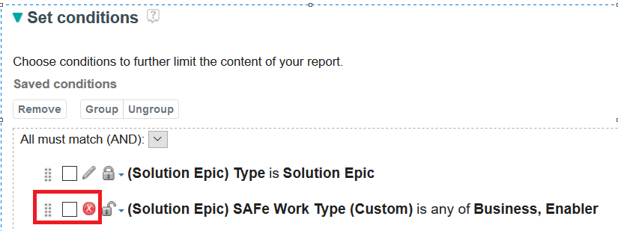

## Improperly Configured Tooling

### You are using a Data Warehouse that is not based on DB2

#### DB2 Advanced SQL Reports

For this archive you may be able to successfully import most of the reports regardless of whether your Data Warehouse is based on DB2, Oracle or SQLServer. There are a few reports that will not import into non-DB2 environments due to SQL syntax errors. If you encounter this, you can create your own version of these reports by using the SQL syntax provided in the **DB2 Advanced SQL.zip** file available on the SAFe Reporting site.

### You have not created the necessary project area(s) in RTC

#### Enterprise Scaled Agile Reports

For this archive you must have either created a Scrum- or SAFe-based project area created in RTC. You may see results as shown in *Figure 1: Missing RTC*  in this case.

If you are sure you have created the proper RTC project area, ensure that you have run ODS Data Collection and that your Report Builder Data Source metadata has been refreshed.

Figure : Missing RTC Metadata

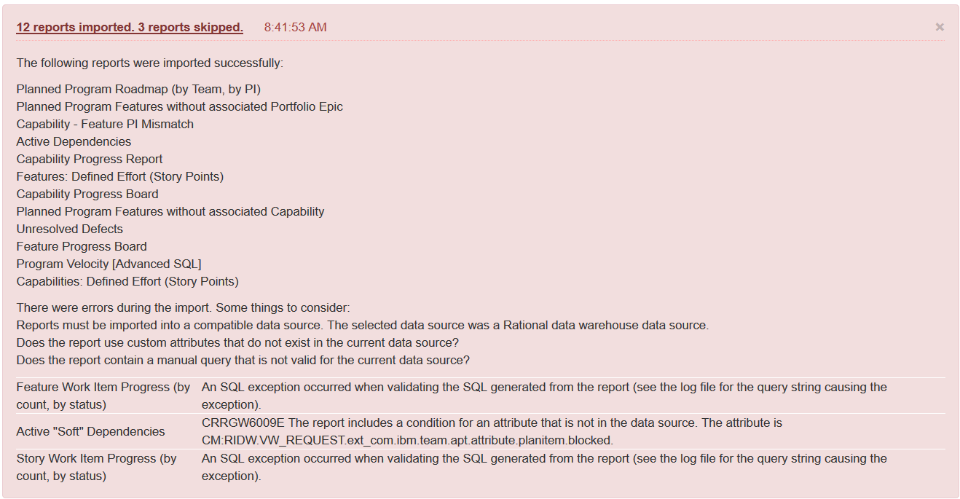

#### SAFe 4.5 Reports

If you have not created any RTC project areas or you have created a Scrum-based project area, and then you attempt to import the SAFe 4.5 reports, you may see results shown in *Figure 2: Missing RTC Metadata (SAFe).*

If you are sure you have created the proper RTC project areas, ensure that you have run ODS Data Collection and that your Report Builder Data Source metadata has been refreshed.

Figure : Missing RTC Metadata (SAFe)

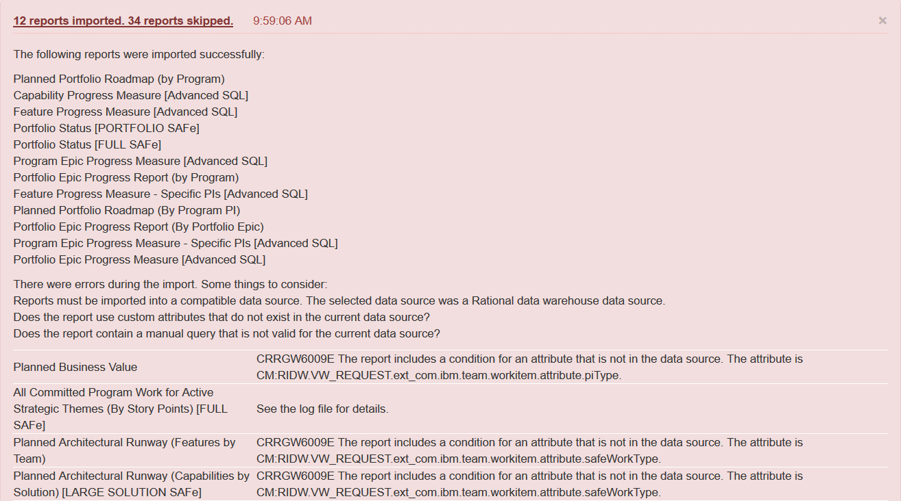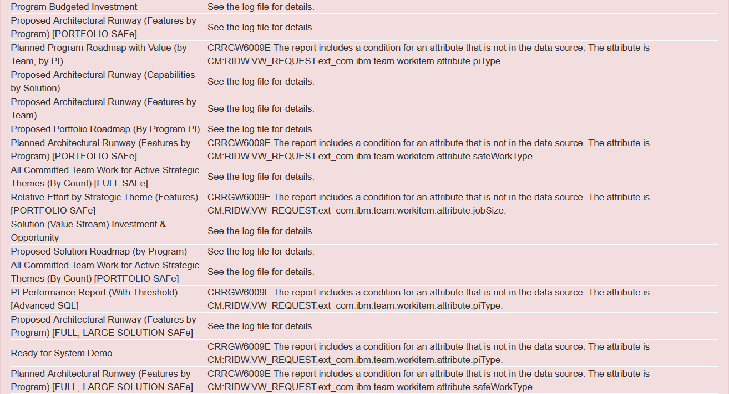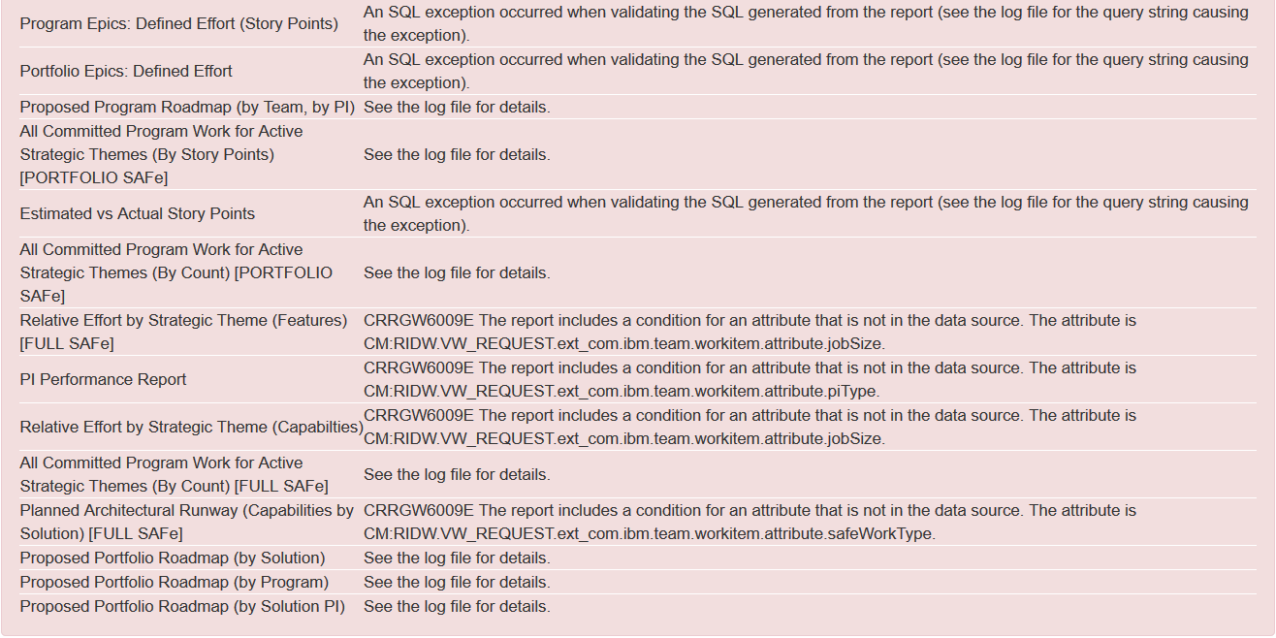

### You are using RTC only (not RDNG or RQM)

#### SAFe 4.5 Reports

There are several SAFe reports that expect RDNG metadata to be present. If you have created an RTC SAFe-based project area, but not an RDNG SAFe Portfolio, Full, or Large Solution project area, you may see results shown in *Figure 3: Missing RDNG Metadata (SAFe)*.

If you do not want to use RDNG, you can ignore these reports that are skipped during import. If you do want to use RDNG and you are sure you have created the proper RTC project area, ensure that you have run ODS Data Collection and that your Report Builder Data Source metadata has been refreshed.

Figure : Missing RDNG Metadata (SAFe)

