I would like this project specific Layout DXL item to appear in the Layout DXL dialog box when adding a Layout DXL Column:

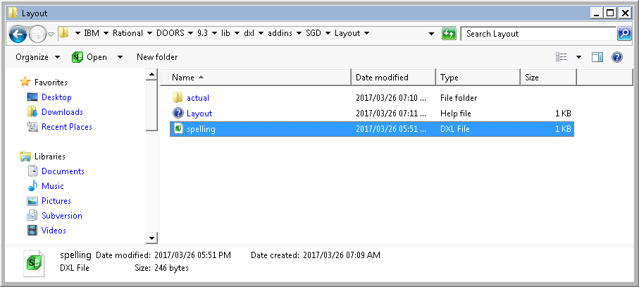

Select the “Layout DXL” option:

Open this item

Add the Layout DXL item

See the standard layout DXL options and see my

project specific layout DXL here.

